# Investigation: Making better boxes and barrels

**Overview of the task and breakdown of components**

* **Component 1**
  + Maximizing the volume of an open-top box (classic problem) with consideration of domain restrictions
  + Consideration of the amount of materials that have been used to create an open-top box
  + Comparing the volume and amount of materials used between a box made of a rectangular sheet of cardboard and a square sheet of cardboard
* **Component 2**
  + Maximizing the volume of a closed-top box with consideration of domain restrictions, and comparing with an open-top box
  + Optimising the volume by varying the length and width with a fixed height, and then optimising the volume by varying the height and fixing the width and length
  + Writing an algorithm using pseudocode to describe the process of finding the volume of a box with the given information and/or optimising the volume of the box
* **Component 3**
  + Using 2 methods to constructing a cylinder from a sheet of metal, and comparing the volume and amount of material wasted.
  + Writing an algorithm using pseudocode to describe the process of finding the volume of a cylinder with the given information, and the corresponding dimensions and materials wasted
  + Finding the dimensions of a cylinder that would maximise volume and minimise the cost of materials

**References:**

* MAV 2020 Methods SAC 2
* Kay Dundas (1984) To Build a Better Box, The Two-Year College Mathematics, Journal, 15:1, 30-36
* Doug French (1988) Investigating Volumes, (Mathematical Association) Mathematics in School, Vol. 17, No. 3 (May, 1988), pp. 27-29

**Introduction**: A local business is getting into manufacturing of small sized containers and barrels. The manufacturing is going to be all automated, however the dimensions and other parameters have to be fed into the manufacturing plant / equipment.

The business is looking for some expert consultants to equip the business with the expertise to work out the best possible dimensions and other parameters from the following perspective

* Maximise the use of material
* Minimise wastage
* Keep the costs low
* Maximise the profit

**Component 1: Open-top box**

Cardboard boxes will be manufactured to hold the beverage cans. Consider a rectangular sheet of cardboard which has a length of $80 cm$ and a width of $50 cm$ that has square corners cut out and sides folded to form an open-top box.

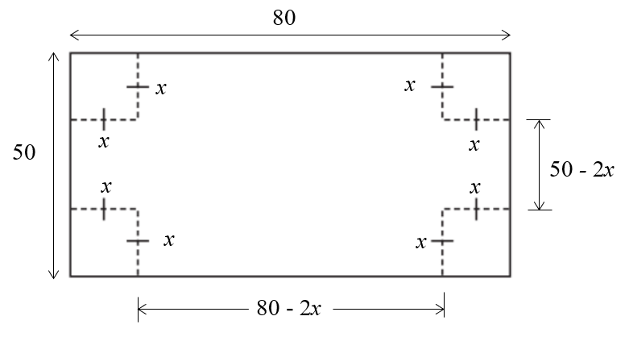 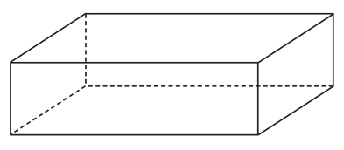

Question 1

1. Show that the volume of the box is given by $V\left(x\right)=4x\left(25-x\right)\left(40-x\right)$
2. Sketch the graph of $V$ against $x$ over a suitable domain. State realistic values of $x$ that would be allowable.
3. Find the maximum possible volume of the box, and the dimensions of the box that correspond to the maximum value.

Waste minimisation is a goal when making carboard boxes. Percentage waste is based on the area of the sheet of cardboard that is cut out before the box is made.

1. Find the percentage of the sheet of cardboard that is wasted for the value of $x$ that gives the maximum volume.
2. Find the maximum possible volume of the box given that at least $3800cm^{2}$ of cardboard can be used (this is inclusive of the corners already being cut out).

Consider a (65 by 65) square sheet of cardboard that has square corners cut out and sides folded to form an open box.

1. Find the maximum possible volume of the box, and the dimensions of the box that would correspond to the maximum volume.
2. Find the percentage of the sheet of cardboard that is wasted.
3. Compare any similarities and differences of the rectangular and square-based boxes. Discuss your results/observations.
4. Would the maximum volume of the box have been different if the dimensions of the rectangular sheet changed, but the perimeter remained the same? Investigate.

Question 2

Consider the open-top square-based box, shown, which has a volume of .

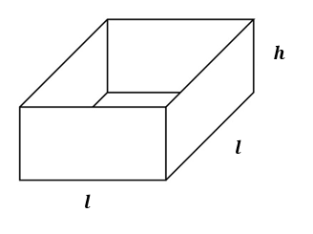

Find:

* 1. in terms of $l$
  2. The surface area, $A$, in terms of $l$
  3. The dimensions of the box that has a minimum surface area, and the corresponding minimum surface area.

**Possible extension:**

Consider a square $a cm×a cm$ piece of cardboard/metal that has square corners of side length $x$ $cm$ 
 cut out and the sides folded to form an open-top box.

1. Find an expression for the volume of the box in terms of $x$ and $a$. State the values of $x$ that would be allowable.
2. Find the maximum volume of the box and the corresponding dimensions, in terms of $a$.
3. For a box of maximum volume, what relationship exists between the side length of the original square piece of cardboard/metal and the side length of the square cut out from each corner?
4. For a box of maximum volume, what relationship exists between the area of the base and the area of the four sides of the walls?
5. Find an expression for the percentage of the sheet of cardboard/metal that is wasted, in terms of $a$.

**Component 2: Closed-top box**

Open-top boxes can at times be impractical as they lack a lid/top.

**Question 1**

Suppose we were to construct a box that is to have a volume of $20,000 cm^{3}$, and we require the ends to be a square $\left(h=w\right)$.

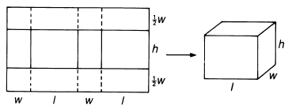

***w***

Find the dimensions of the box that would correspond to the minimum (area) amount of cardboard being used, and the dimensions of the sheet of cardboard that would be used to construct the box. Comment on any geometrical significance of your result(s).

Write an algorithm using pseudocode that could be used to gives the dimensions of the box, and the dimensions of the sheet of cardboard that would be used to construct the box. (Note: It does not necessarily have give the dimensions of the box with minimum area).

If you’re finding it tricky to get started, consider choosing values for $w$ and $l$ that would give a volume of $20,000 cm^{3}$ and then vary the dimensions of the box.

**Question 2**

One method to construct a closed-top box is shown below, where we can cut along the solid lines and fold along the dashed lines. Well-placed sticky tape or staples can be used to secure a fairly usable box

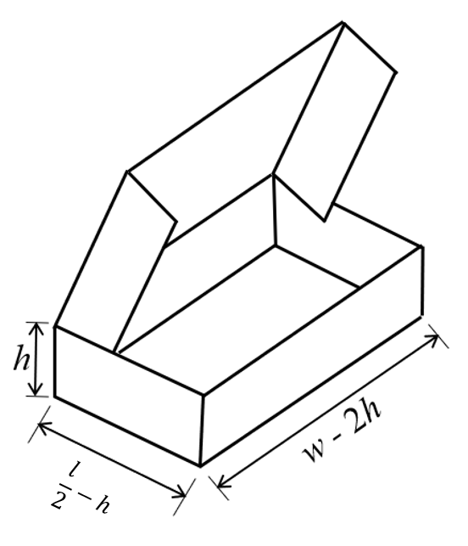

Consider the case where the length of the cardboard sheet is $12 cm$ and the width of the cardboard sheet is $12 cm$ $($ i.e. $w=l=12)$. The height of the box, $T$, is allowed to vary.

1. Show that the volume of the closed-top box above is given by $V\left(h\right)=2h{\left(6-h\right)}^{2}$
2. Find the maximum possible volume of the closed-top box, and the dimensions of the box that correspond to the maximum value.
3. Compare your results to an open-top box that is constructed from a $12 cm×12cm$ sheet of cardboard.

Restricting the shape of the rectangular piece of cardboard limits the maximum volume of the closed-top box.

Suppose an $A cm^{2}$ sheet of cardboard is used to construct a closed-top box in the same manner above.

1. By fixing the height at $h cm$, find the dimensions of the rectangular sheet of cardboard that corresponds to the box that has maximum volume. Find the corresponding maximum volume. (Hint: It will help to express $w$ in terms of $l$).
2. Using your values obtained in part d., by fixing the length $\left(l\right)$ and width $\left(w\right)$, find the height $h$ that will maximise the volume of the closed-top box. Find the corresponding maximum volume.

**Component 3: Cylindrical Barrels**

A barrel used to contain liquids are to be manufactured from rectangular sheets of metal   
(80 cm by 50 cm) into a cylindrical shape, as shown below.

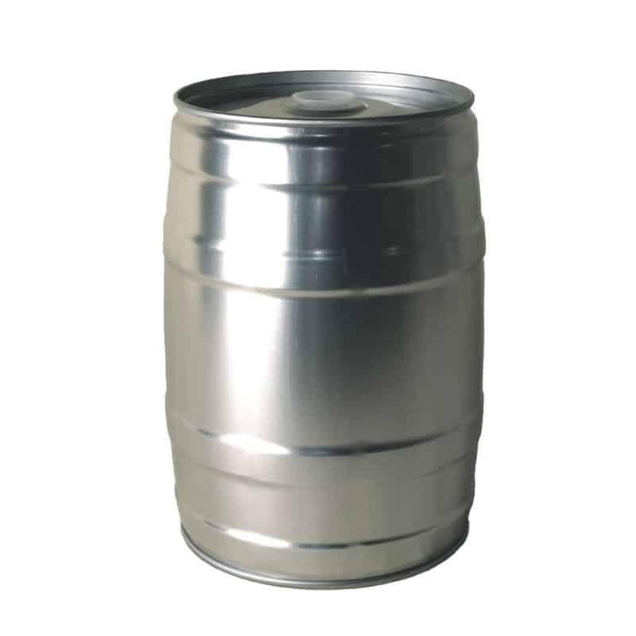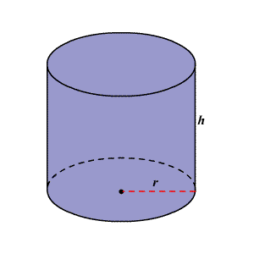

The business owner has a choice of two ways of manufacturing the barrels, as shown below.

Method 1 Method 2

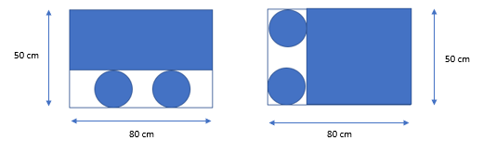

1. By selecting suitable values of $r$ and $h$, create your own barrel using both methods.

* State any assumptions made
* Explain why your chosen values of $r$ and $h$ are suitable
* State the volume of your two barrels
* State the amount of material used to create your barrels and the wastage

1. Write an algorithm using pseudocode that would give the volume, dimensions, and wastage of each cylinder.
2. For each method of constructing the cylindrical barrel, find:

* The maximum possible volume
* The corresponding dimensions
* The amount of material used and the wastage

1. Which of the two construction methods would you recommend to the business owner? Justify your reasoning.
2. Compare the volume and wastage of the cylindrical barrel with the closed-top box that is made with the same dimensions of sheet (80 x 50).

The business owner is also looking at manufacturing cylindrical barrels to store larger volumes of liquids.

The top and bottom (circles) are made from metal that costs $0. 001 per square centimetre while the curved wall of the barrel (curved rectangle) is made from metal that costs $0.0004 per square centimetre.

1. What should be the radius and height of the barrel that would minimize the materials cost? State the cost per barrel.

Extension:

How many cans can fit in the box

What would the size of the box be to fit in cans

12-13 cm high for a real-life can

How to get best value…