# Investigation: Making better boxes and barrels – Possible Responses

**Component 1: Open-top box**

Cardboard boxes will be manufactured to hold the beverage cans. Consider a rectangular sheet of cardboard which has a length of $80 cm$ and a width of $50 cm$ that has square corners cut out and sides folded to form an open-top box.

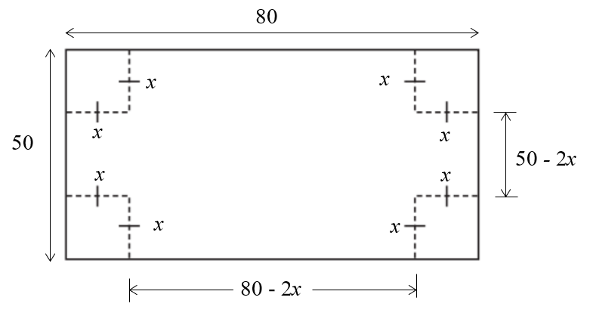 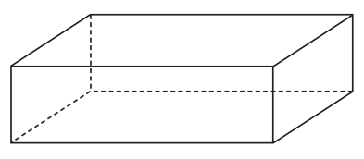

Question 1

1. Show that the volume of the box is given by $V\left(x\right)=4x\left(25-x\right)\left(40-x\right)$
$$V=x×\left(50-2x\right)×\left(80-2x\right)$$

$$V=4x\left(25-x\right)\left(40-x\right)$$

2. Sketch the graph of $V$ against $x$ over a suitable domain. State realistic values of $x$ that would be allowable.

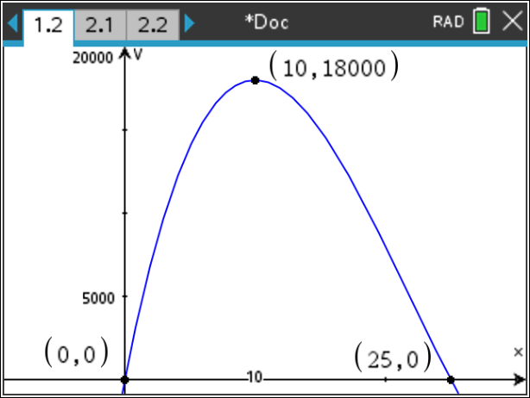

$0<x<25$ (Note: This could be an opportunity where students could discuss or explain their choice of endpoints and why they are suitable within the given context)

1. Find the maximum possible volume of the box, and the dimensions of the box that correspond to the maximum value.

Two approaches could be using calculus or using a graphical approach with CAS.

|  |  |
| --- | --- |
| Method 1: Calculus  Graphical user interface, text, application, email  Description automatically generated  is taken due to the domain | Method 2: Graphical Approach    Students can use the Analyse Graph features of the TI-Nspire to find the coordinates of the maximum point on the graph, and will then need to interpret the $x$ and $y$ values. |
| In both instances, the dimensions of the box are:  Height is 10 cm  Width is 60 cm  Length of 30 cm (Note width or length could be interchanged)  Alternatively written as $10cm×30cm×60cm$ (in any order) | |

Waste minimisation is a goal when making carboard boxes. Percentage waste is based on the area of the sheet of cardboard that is cut out before the box is made.

1. Find the percentage of the sheet of cardboard that is wasted for the value of $x$ that gives the maximum volume.

$$\frac{4×{10}^{2}}{80×50}×100=10\%$$

Students could generalise this to $\frac{4x^{2}}{w×l}×100$

1. Find the maximum possible volume of the box given that at least $3800cm^{2}$ of cardboard can be used (this is inclusive of the corners already being cut out).

There are a couple of paths that students could take in solving this problem. Two possible paths are considered here.

**Path 1**

The area of the $80cm×50cm$ sheet with corners cut out   
would be given by $A=4000-4x^{2}$

From earlier, we know the domain is $0<x<25$,  
and the maximum possible volume of the box occurred for .

From the graph, it can be seen that in order to have the area of the sheet used to be at least $3800 cm^{2}$ we need $x$ to be less than 10. Specifically, we need $x$ to be at most $5\sqrt{2}≈7.07 cm$.

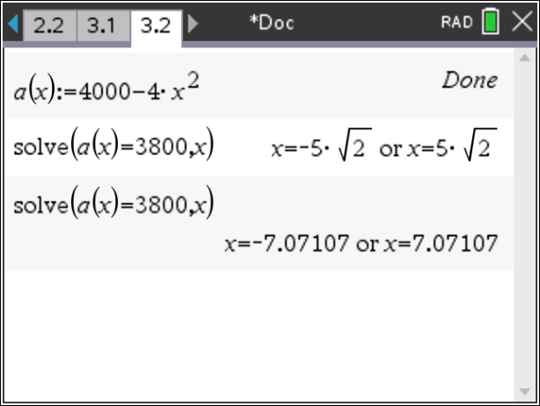

From earlier, our volume against $x$ tells us that as $x$ gets cloder to $10$, the volume will be a maximum, and the further away from 10 $x$ becomes, the volume will decrease.



This suggests that the volume will be maximised when $x=5\sqrt{2}$, which will correspond to an area of $3800 cm^{2}$. The maximum volume will be approximately $16698.5 cm^{3}$

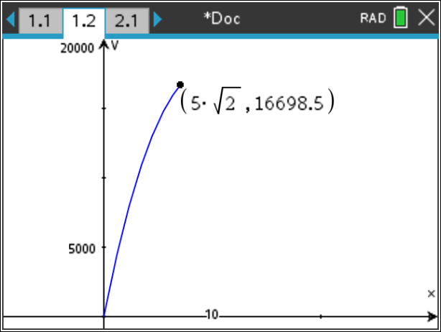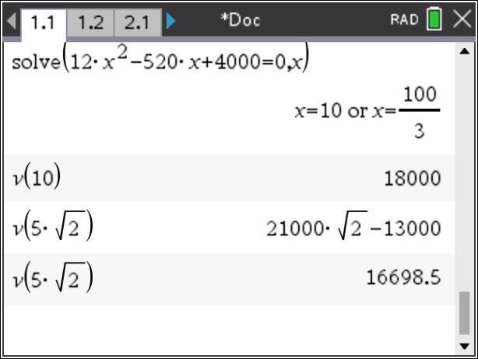

**Path 2**

The area of the $80cm×50cm$ sheet with corners cut out   
would be given by $A=4000-4x^{2}$

From earlier, we know the domain is $0<x<25$  
and the volume is given by $V=4x^{3}-260x^{2}+4000x$.

Obtaining $x$ in terms of $A$ gives $x={\left(\frac{4000-A}{4}\right)}^{\frac{1}{2}}$. From here, $V$ can be expressed in terms of $A$.

$$V=4{\left(\frac{4000-A}{4}\right)}^{\frac{3}{2}}-260\left(\frac{4000-A}{4}\right)+4000{\left(\frac{4000-A}{4}\right)}^{\frac{1}{2}}$$

Sketching $V$ against $A$, with the domain restriction, informs us that the maximum volume will be approximately $16698.5 cm^{3}$ and corresponds to an area of $3800 cm^{2}$.

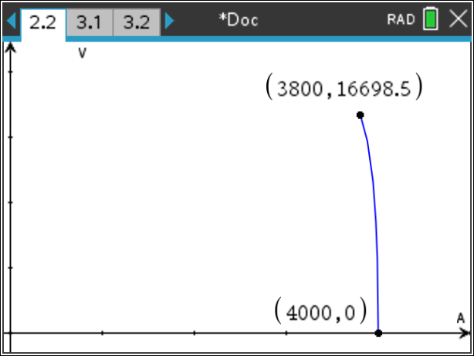

Consider a (65 by 65) square sheet of cardboard that has square corners cut out and sides folded to form an open box.

1. Find the maximum possible volume of the box, and the dimensions of the box that would correspond to the maximum volume.

The volume is given by $V=x{\left(65-2x\right)}^{2}$ and the maximal domain is $0<x<\frac{65}{2}$

Using either of the approaches as mentioned in the case of the rectangular box (calculus or using a graph), the maximum volume is $20342.6 cm^{3}$, which Is corresponds to an $x$ value of $\frac{65}{6}$ cm.

The dimensions of the box are $\frac{65}{6}cm×\frac{130}{3} cm×\frac{130}{3} cm$ (or $10.83 cm×43.33 cm×43.33 cm$)

1. Find the percentage of the sheet of cardboard that is wasted.
$$\frac{4×{\left(\frac{65}{6}\right)}^{2}}{{\left(\frac{65}{6}\right)}^{2}}×100=\frac{100}{9}\%≈11.11\%$$

2. Would the maximum volume of the box have been different if the dimensions of the rectangular sheet changed, but the perimeter remained the same? Investigate.

This is an open question, where students could use any methods/strategies at their disposal to generate and verify their conclusions. Below is one example.

First, begin with a specific example (base case). So far we’ve seen a rectangle and a square that both have a perimeter of $260 cm$. Consider a $100cm×30cm$ rectangle, which will also have a perimeter of $260 cm$.

The volume is of the open-topped box formed is given by $V=2x(50-x)(15-x)$.

The maximum possible volume of the box is $9628.47$, and corresponds to $x=6.85 cm$ (2dp).

A summary of our observations so far:

|  |  |  |  |
| --- | --- | --- | --- |
|  | $$80×50$$ | $$65×65$$ | $$100×30$$ |
| Max volume | $$18,000$$ | $$20342$$ | $$9628.47$$ |
| Area of sheet | $$4000$$ | $$4225$$ | $$3000$$ |
| $$x_{max}$$ | $$10$$ | $$10.83$$ | $$6.85$$ |

In the summary table, it is clear that the volume will vary as the dimensions vary given that the perimeter is fixed. It appears that the volume of the box increases when the area of the sheet used increases.

From here, students could investigate this conjecture further.

Consider a sheet of width $w$ cm and a length of $l cm$ which gives a perimeter of $P=2\left(w+l\right)$ cm.

The volume of the box is given by $V=x\left(w-2x\right)\left(l-2x\right)$

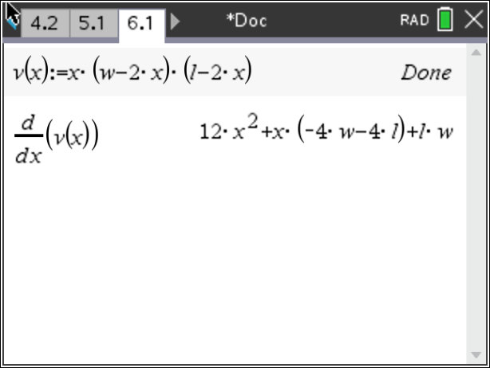

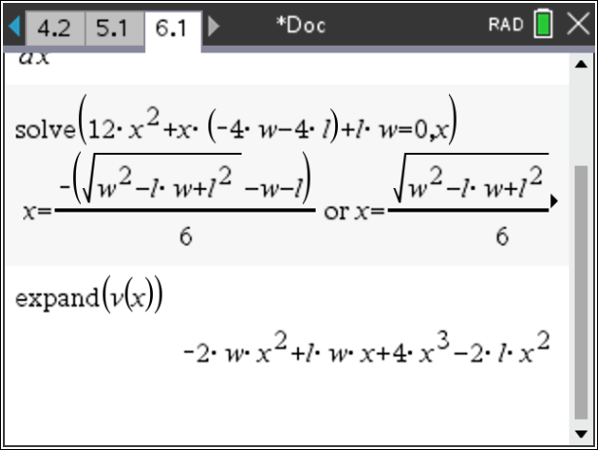

The volume, in expanded form is $V=4x^{3}-2\left(l+w\right)x^{2}+lwx=4x^{3}-Px^{2}+Ax$, where $P$ is the perimeter and $A$ is the area of the sheet.

From the volume equation, and the value of $x$ that gives the optimum volume, it can be seen that the volume will be optimal when the area increases, as $P$ is constant.

Given that $l+w=\frac{P}{2}$ and $lw=A$, we can obtain $A=l\left(\frac{P}{2}-l\right)$; a parabola with intercepts at $(0,0)$ and $\left(\frac{P}{2},0\right)$, and whose turning point will occur midway between the intercepts at $\left(\frac{P}{4},\frac{P^{2}}{16}\right)$.

This suggests that $w=\frac{P}{4}$ and that the volume will be a maximum when the sheet used for construction is a square.

Question 2

Consider the open-top square-based box, shown, which has a volume of .

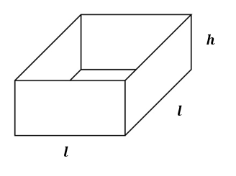

Find:

* 1. in terms of $l$ and $V$.
 $$V=hl^{2}$$

 $$h=\frac{V}{l^{2}}$$

2. The surface area, $A$, in terms of $l$ and $V$.
 $$A=l^{2}+4lh$$

 $$A=l^{2}+\frac{4V}{l}$$

3. The dimensions of the box that has a minimum surface area, and the corresponding minimum surface area.

$$\frac{dA}{dl}=0$$

$$l={\left(2V\right)}^{\frac{1}{3}} cm$$

$$h={\left(\frac{V^{2}}{2}\right)}^{\frac{1}{3}} cm$$

$$A=3{\left(2V\right)}^{\frac{2}{3}} cm^{2}$$

**Possible extension:**

Consider a square $a cm×a cm$ piece of cardboard/metal that has square corners of side length $x$ $cm$ 
 cut out and the sides folded to form an open-top box.

1. Find an expression for the volume of the box in terms of $x$ and $a$. State the values of $x$ that would be allowable.
2. Find the maximum volume of the box and the corresponding dimensions, in terms of $a$.
3. For a box of maximum volume, what relationship exists between the side length of the original square piece of cardboard/metal and the side length of the square cut out from each corner?
4. For a box of maximum volume, what relationship exists between the area of the base and the area of the four sides of the walls?
5. Find an expression for the percentage of the sheet of cardboard/metal that is wasted, in terms of $a$.

**Component 2: Closed-top box**

Open-top boxes can at times be impractical as they lack a lid/top.

**Question 1**

Suppose we were to construct a box that is to have a volume of $20,000 cm^{3}$, and we require the ends to be a square $\left(h=w\right)$.

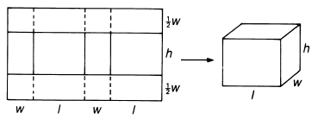

***w***

Find the dimensions of the box that would correspond to the minimum (area) amount of cardboard being used, and the dimensions of the sheet of cardboard that would be used to construct the box. Comment on any geometrical significance of your result(s).

$$V=20000=w^{2}l$$

$$l=\frac{20000}{w^{2}}$$

$$A=2w^{2}+4wl$$

$$A=2w^{2}+\frac{80000}{w}$$

$$\frac{dA}{dw}=0$$

$$w≈27.14 cm$$

$A≈4420.84 cm^{2}$ and $l≈27.14 cm$

The box with a minimum surface area is one which has square sides (a cube).

Write an algorithm using pseudocode that could be used to gives the dimensions of the box, and the dimensions of the sheet of cardboard that would be used to construct the box. (Note: It does not necessarily have give the dimensions of the box with minimum area).

If you’re finding it tricky to get started, consider choosing values for $w$ and $l$ that would give a volume of $20,000 cm^{3}$ and then vary the dimensions of the box.

**Question 2**

One method to construct a closed-top box is shown below, where we can cut along the solid lines and fold along the dashed lines. Well-placed sticky tape or staples can be used to secure a fairly usable box.

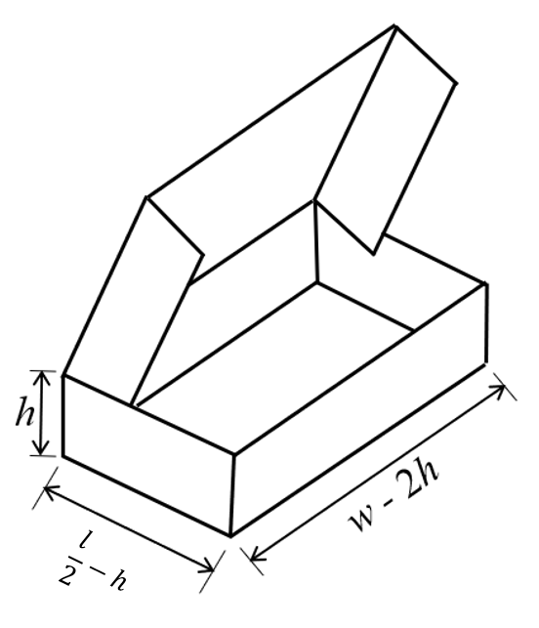

Consider the case where the length of the cardboard sheet is $12 cm$ and the width of the cardboard sheet is $12 cm$ $($ i.e. $w=l=12)$. The height of the box, $h$, is allowed to vary.

1. Show that the volume of the closed-top box above is given by $V\left(h\right)=2h{\left(6-h\right)}^{2}$

$$V=h\left(\frac{l}{2}-h\right)\left(w-2h\right)$$

$$V=\frac{h}{2}\left(l-2h\right)\left(w-2h\right)$$

$l=12$ and $w=12$

$$V=\frac{h}{2}{\left(12-2h\right)}^{2}$$

$$V=2h{\left(6-h\right)}^{2}$$

1. Find the maximum possible volume of the closed-top box, and the dimensions of the box that correspond to the maximum value.

$$\frac{dV}{dh}=0$$

$$h=2 cm, V=64 cm^{3}$$

Length of box is $4 cm$ and the width of the box is $8 cm$.

1. Compare your results to an open-top box that is constructed from a $12 cm×12cm$ sheet of cardboard.

For an open-top box, $V=h{\left(12-2h\right)}^{2}$

The maximum volume of the box is $128 cm^{3}$, which corresponds to a height of $2 cm$, a width of $8 cm$ and a length of $8 cm$.

The open-top box is double the volume and double the length of the closed-top box for the same corresponding height, where the same sheet of cardboard with the same dimensions has been used.

Restricting the shape of the rectangular piece of cardboard limits the maximum volume of the closed-top box.

Suppose an $A cm^{2}$ sheet of cardboard is used to construct a closed-top box in the same manner above.

1. By fixing the height at $h cm$, find the dimensions of the rectangular sheet of cardboard that corresponds to the box that has maximum volume. Find the corresponding maximum volume. (Hint: It will help to express $w$ in terms of $l$).

$$A=wl$$

$$w=\frac{A}{l}$$

$$V=h\left(\frac{l}{2}-h\right)\left(w-2h\right)$$

$$V=2h\left(l-2h\right)\left(w-2h\right)$$

$$V=2h\left(l-2h\right)\left(\frac{A}{l}-2h\right)$$

$$\frac{dV}{dl}=0$$

$l=\sqrt{A} cm$

$w=\sqrt{A} cm$ and $V=2h{\left(\sqrt{A}-2h\right)}^{2}$

Dimensions of the rectangular sheet of cardboard are $\sqrt{A} cm×\sqrt{A} cm$ (which happens to be a square!)

1. Using your values obtained in part d., by fixing the length $\left(l\right)$ and width $\left(w\right)$, find the height $h$ that will maximise the volume of the closed-top box. Find the corresponding maximum volume.

$$V=h\left(\frac{l}{2}-h\right)\left(w-2h\right)$$

Now taking the fixed length and width of the sheets as $\sqrt{A} cm$ from part d., we have

$$V=h\left(\frac{\sqrt{A}}{2}-h\right)\left(\sqrt{A}-2h\right)$$

$$V=\frac{h}{2}\left(\sqrt{A}-2h\right)\left(\sqrt{A}-2h\right)$$

$$\frac{dV}{dh}=0$$

$h=\frac{\sqrt{A}}{6}$ and $V=\frac{A^{\frac{2}{3}}}{27}$

**Component 3: Cylindrical Barrels**

Barrels which are used to contain liquids are to be manufactured from rectangular sheets of metal   
(80 cm by 50 cm) into a cylindrical shape, as shown below.

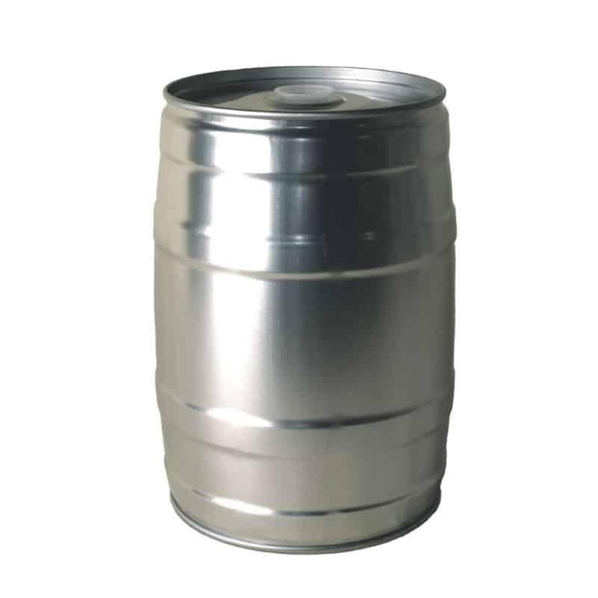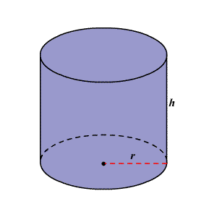

The business owner has a choice of two ways to manufacture the barrels, as shown below.

Method 1 Method 2

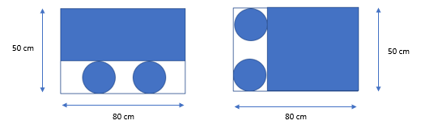

1. By selecting suitable values of $r$ and $h$, create your own barrel using both methods.

* State any assumptions made
* Explain why your chosen values of $r$ and $h$ are suitable
* State the volume of your two barrels
* State the amount of material used to create your barrels and the wastage

**Method 1**

$$h+2r=50$$

$$h=50-2r$$

$$0<2πr<80$$

$$0<r≤12.73$$

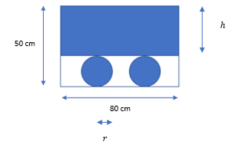

Take $r=10$ and $h=30$. The chosen values adhere to the physical constraints and would produce a barrel with the given sheet of material. The circumference of the circular top & bottom is $20π≈ 62.83$  
 cm, which is less than 80 cm, and therefore the $30×50$ rectangular sheet can be folded (or cut) to make a circumference of $62.83$ cm.

$$V=π{\left(10\right)}^{2}×30=3000π≈9424.78 cm^{3} or 9424.78 mL$$

Amount of material used is $80×30+2π{\left(10\right)}^{2}≈3028.32 cm^{2}$

Amount wasted is $4000-3028.32≈971.68 cm^{2}$ (which is approx. 24.29%)

**Method 2**

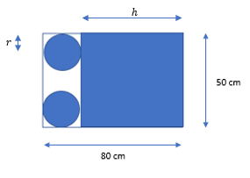

$$h+2r=80$$

$$h=80-2r$$

$$0<2πr<50$$

$$0<r≤7.96$$

Take $r=5$ and $h=70$. The chosen values adhere to the physical constraints and would produce a barrel with the given sheet of material. The circumference of the circular top & bottom is $10π≈ 31.42$  
 cm, which is less than 50 cm, and therefore the $70×50$ rectangular sheet can be folded (or cut) to make a circumference of $31.42$ cm.

$$V=π{\left(5\right)}^{2}×70=1750π≈5497.79 cm^{3} or 5497.79 mL$$

Amount of material used is $50×70+2π{\left(5\right)}^{2}≈3657.08 cm^{2}$

Amount wasted is $4000-3657.08≈342.92 cm^{2}$ (which is approx. 8.57%)

1. Write an algorithm using pseudocode that would give the volume, dimensions, and wastage of each cylinder.
2. For each method of constructing the cylindrical barrel, find:

* The maximum possible volume
* The corresponding dimensions
* The amount of material used and the wastage

1. Which of the two construction methods would you recommend to the business owner? Justify your reasoning.
2. Compare the volume and wastage of the cylindrical barrel with the closed-top box that is made with the same dimensions of sheet (80 x 50).

The business owner is also looking at manufacturing cylindrical barrels to store larger volumes of liquids.

The top and bottom (circles) are made from metal that costs $0. 001 per square centimetre while the curved wall of the barrel (curved rectangle) is made from metal that costs $0.0004 per square centimetre.

1. What should be the radius and height of the barrel that would minimize the materials cost? State the cost per barrel.

First, consider the maximum possible volume of a barrel.

**Method 1**

$V=πr^{2}(50-2πr)$ $0<r≤12.73$

$r_{max}=12.73$ $cm$ $V_{max}=12493.4 cm^{3}$ $h_{max}=24.54 cm$

**Method 2**

$V=πr^{2}(80-2πr)$ $0<r≤7.96$

$r_{max}=7.96$ $cm$ $V_{max}=12755.5 cm^{3}$ $h_{max}=64.08 cm$

Now consider the cost.

$$C=0.001×2πr^{2}+0.0004×2πrh$$

**Method 1: $h=50-2r$**

$C=0.001×2πr^{2}+0.0004×2πr(50-2r)$, where $0<r≤12.73$

$C\left(12.73\right)=1.80$ dollars per barrel

**Method 2: $h=80-2r$**

$C=0.001×2πr^{2}+0.0004×2πr(80-2r)$, where $0<r≤7.96$

$C\left(7.96\right)=1.68$ dollars per barrel

Method 2 can result in a barrel with a larger volume for a lower cost of production compared with method 1.

$r=7.96$ $cm$ $h=64.08 cm$

Extension:

How many cans can fit in the box

What would the size of the box be to fit in cans

12-13 cm high for a real-life can

How to get best value…