Investigation: Product of Polynomials
Overview of the task and breakdown of components
- Component 1
  - Sketching cubic graphs of the form $y=(x-a)(x-b)(x-c)$
  - Sketching cubic graphs of the form $y=\left(x-a\right){\left(x-b\right)}^{2}$
  - Sketching cubic graphs of the form $y={\left(x-a\right)}^{3}$
  - Recognising the connection between the values of $a, b, c$ and the $x$-interepts
  - Recognising the connection between the degree of a factor and the behaviour of the cubic graph at the $x$-intercept(s)
  - Summarising and generalising results/observations through comparison of examples or pattern recognition, and using mathematical notation and/or everyday language to describe generalisations
- Component 2
  - Sketching graphs of the form $y=x^{m}{\left(h-x\right)}^{n}$ for given values of $n$ and $m$
  - Recognising the connection between the degree of a factor and the behaviour of the polynomial graph at the $x$-intercept(s)
  - Recognising the connection between the degree of the polynomial and the overall shape/behaviour of the graph
  - Summarising and generalising results/observations through comparison of examples or pattern recognition, and using mathematical notation and/or everyday language to describe generalisations
- Component 3
  - Sketching graphs of the form $y=\left(x^{m}-a\right)\left(x^{n}-b\right)$ for given constraints
on $m$ and $n$
  - Recognising the importance of fully factorising an expression to locate and identify the key features of a graph
  - Summarising and generalising results/observations through comparison of examples or pattern recognition, and using mathematical notation and/or everyday language to describe generalisations
Possible ways to implement such a task
- Would typically spend maybe half a week to one week on higher-order polynomial graphs.
- Could replace textbook work with such a task (Instead of Ch6-whatever from Cambridge or Ch5-whatever from Jacaranda).
- As part of the task, it would be advised for students to summarise/comment on what they are observing/finding (e.g. what is similar/different? What do you notice?) and what they have learnt/understood. There’s often a discrepancy between what we tell/teach students and what they understand (or interpret what we say).
- Such a task could be for formative assessment purposes, with no weighting assigned to the investigation. Its primary function is a learning instrument. There could be a summative assessment (test) for the entire cubics/polynomials topic that assesses ideas explored in the investigation.

TI Video YouTube links (Sliders and maybe some useful commands)

Inserting and Using Sliders | TI-Nspire CX II | Getting Started Series - Graphs Application
https://www.youtube.com/watch?v=jHY6X5Er0Ew

Sliders in Notes | TI-Nspire CX II CAS | Getting Started Series - Notes Application
https://www.youtube.com/watch?v=b4pt8R_0HzM
For additional support: https://education.ti.com/en-au/resources/getting-started-with-ti-technology/student-course-lessons-ti-nspire-cx-ii-cas

Component 1
In this component you will consider graphs of cubic polynomials.
- Consider the family of curves of the form $y=(x-a)(x-b)(x-c)$ where $a,b,c$ are real numbers $(a,b,c∈R)$.
- i. By selecting your own values for $a, b, c,$ where $a≠b≠c$, sketch 3 cubic graphs of the above form. Label your axial intercepts with coordinates. Also write the equation for each corresponding graph.
- Comment on any similarities/differences between your graphs.
- Discuss how $a,b,c$ affect the key features of the graph.
- What happens to the shape and key features of the cubic graph if $a=b=c$? Investigate. Provide 3 examples to support your ideas/conjectures. Label your axial intercepts with coordinates. Also write the equation for each corresponding graph.
Comment on any similarities/differences. Try to generalise your observations.
- What happens to the shape and key features of the cubic graph if $a=b≠c$? Investigate. Provide 3 examples to support your ideas/conjectures. Label your axial intercepts with coordinates. Also write the equation for each corresponding graph.
Comment on any similarities/differences. Try to generalise your observations.
- Consider the family of curves of the form $y=(x-1)(ax^{2}+bx+c)$,
where $a,b,c$ are non-zero real numbers.
Investigate how $a,b,c$ affect the shape and key features of the graph.
Provide examples to support your ideas/conjectures. Summarise/describe your observations, and try to generalise your observations.

Component 2
In this component you will consider graphs of the form $y=x^{m}{\left(h-x\right)}^{n}$, where $h$ is non-zero real number and $m,n∈\left\{0, 1, 2, 3, 4\right\}$
- Consider the case where $h=2$.
- Sketch the following graphs, labelling all key features.
$$m=0, n=0$$ | $$y=x^{0}{\left(2-x\right)}^{0}$$ | $$m=1, n=1$$ | $$y=x(2-x)$$
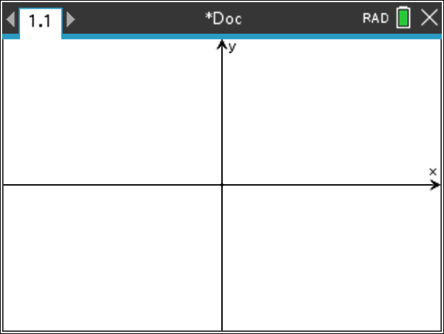
$$m=2, n=1$$ | $$y=x^{2}\left(2-x\right)$$ | $$m=1, n=2$$ | $$y=x{\left(2-x\right)}^{2}$$
$$m=3, n=1$$ | $$y=x^{3}\left(2-x\right)$$ | $$m=1, n=3$$ | $$y=x{\left(2-x\right)}^{3}$$
$$m=2, n=2$$ | $$y=x^{2}{\left(2-x\right)}^{2}$$

- Comment on any similarities/differences between your graphs.
- Discuss how $m$ and $n$ affect the behaviour/shape of the graph. Provide examples to support your ideas/conjectures (select a different value of $h$).
- Discuss how $m$ and $n$ affect the number and nature of any turning points/point of inflection. Provide examples to support your ideas/conjectures (select a different value of $h$).
- What would happen to the graph and key features if $h$ was negative? Investigate.
- Create an equation of a graph of the form $y=x^{m}{\left(h-x\right)}^{n}$ that satisfies the following conditions:
Graph 1:
- Has an $x$-intercept and turning point at $x=3$
Graph 2:
- Has at least 2 turning points
- Has a negative $x$-intercept
Graph 3:
- Has a stationary point of inflection
- Has a negative $x$-intercept

Component 3
In this component you will consider graphs of the form $y=(x^{m}-a)(x^{n}-b)$,
where $a,b$ are non-zero real numbers and $m,n∈\left\{1, 2, 3\right\}$.
- Consider the family of curves of the form $y=\left(x^{m}-1\right)\left(x^{n}-8\right)$ where $2≤m+n≤4$.
Investigate how $m$ and $n$ affect:
- The location and number of axial intercepts
- The behaviour of the graph
- (The number of turning points/stationary points of inflection)

- Consider the family of curves of the form $y=\left(x^{m}-1\right)\left(x^{n}-a\right)$ where $2≤m+n≤4$ and $a$ is a non-negative real number.
Investigate how $a, m$ and $n$ affect:
- The location and number of axial intercepts
- The behaviour of the graph
- (The number of turning points/stationary points of inflection)

End of Investigation

