**Using Mathematica as an Effective Tool in Teaching**

Brian Stokes

Monash University

Wolfram Mathematica 11 Version 11.0.1.0

**Introduction**

The following presentation introduces the basics of Wolfram Mathematica including number representation, algebraic manipulation, solving equations, plotting graphs, differentiation, limits, integration and differential equations. In addition, parametric plots and multiple function plots will be discussed as well as basic commands in statistics *inter alia*.

**Conventions**

All commands and instructions will be written in **Courier Bold Face Type** and Mathematica output in Courier Light Face Type.

**The Kernel and the Front End**

The kernel is the computational engine of Mathematica. You input instructions and the kernel responds with answers in the form of numbers, graphs and matrices. The kernel works silently in the background.

The interface between the user and the kernel is called the front end and the medium of the front end is the Mathematica notebook. The notebook enables you to communicate with the kernel.

To execute an instruction, type the instruction and then press ENTER with the shift key held down.

The most common mathematical symbols can be accessed by clicking on PalettesBasicMathInput. Then mouse click the desired symbol.

However, each Mathematica symbol can be typed manually. For example,  can be represented by **Pi** and  can be written **Sqrt[5].**

The notebook is where you input your commands and where Mathematica places the result of your calculations.

A semicolon (**;**) at the end of a command will suppress the output. This is useful in long sequences of calculations when only the final answer is important.

To abort a calculation, go to EvaluationAbortEvaluation.

To include comments with your commands, anything written within (**\***and **\***) is ignored by the Mathematica kernel.

To get started go to New Document and then Notebook.

**SOLVED PROBLEMS**

**Problem 1**

Multiply 12 by 17 and then add 9.

**Solution**

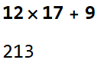

**Problem 2**

Multiply 17.2 by 16.3 and then add 4.7.

**Solution**

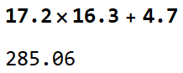

**Problem 3**

Multiply 17.2 by the sum of 16.3 and 4.7.

**Solution**

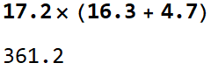

**Problem 4**

Compute the sum of 2*x* + 3, 5*x* + 9 and 4*x* + 2.

**Solution**

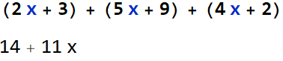

**Problem 5**

Compute .

**Solution**

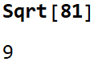

**Problem 6**

Use parentheses to multiply the sum of 2 and 3 by the sum of 5 and 7.

**Solution**

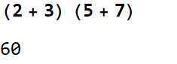

**Problem 7**

Compute sin().

**Solution**

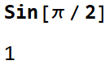

**Problem 8**

Simplify +  + .

**Solution**

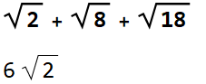

**Problem 9**

Compute the sum of the reciprocals 0f 3, 5, 7, 9 and 11.

**Solution**

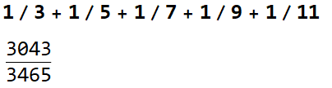

**Problem 10**

Multiply  by .

**Solution**

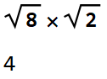

**Problem 11**

Simplify  +  +  +  leaving your answer in radical form.

**Solution**

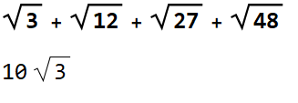

**Problem 12**

Define *a* = 3, *b* = 4 and *c* = 5. Then multiply the sum of *a* and *b* by the sum of *b* and *c*. Print only the final answer.

**Solution**

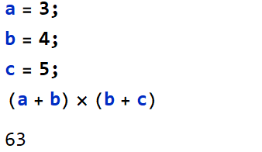

**Problem 13**

Obtain a 25-decimal approximation of *e*, the base of the natural logarithm.

**Solution**

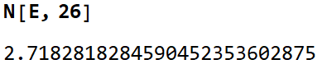

**Problem 14**

Express  +  -  +  as an approximation to 15 decimal places.

**Solution**

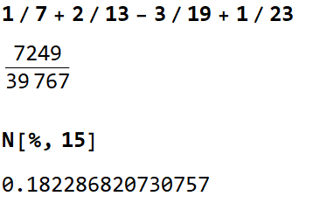

**Problem 15**

Let *a* = 2*x* + 3*y* + 4*z*, *b* = *x* + 3*y* + 5*z* and *c* = 3*x* + *y* + *z*. Compute the sum of *a*, *b*, and *c* printing only the final result.

**Solution**

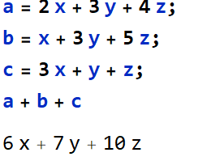

**Problem 16**

Obtain an 11 significant digit approximation to .

**Solution**

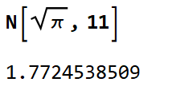

**Problem 17**

Solve the algebraic equation *x*3 – 2*x* + 1 = 0.

**Solution**

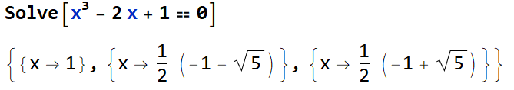

**Problem 18**

Express (*x* + 1)10 in traditional polynomial form.

**Solution**



**Problem 19**

What is the 1000th prime number?

**Solution**

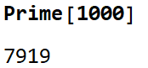

**Problem 20**

Compute the atomic weight and the atomic number of titanium.

**Solution**

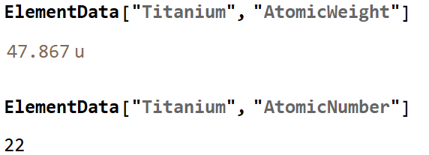

**Problem 21**

Plot the graph of y = sin *x* from 0 to 2.

**Solution**

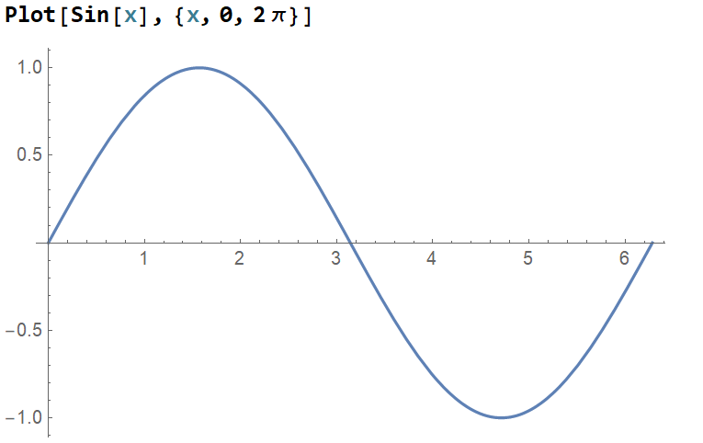

**Problem 22**

Sketch the graphs of *y* = sin *x*, *y* = sin 2*x* and *y* = sin 3*x*, 0 2, on one set of axes.

**Solution**

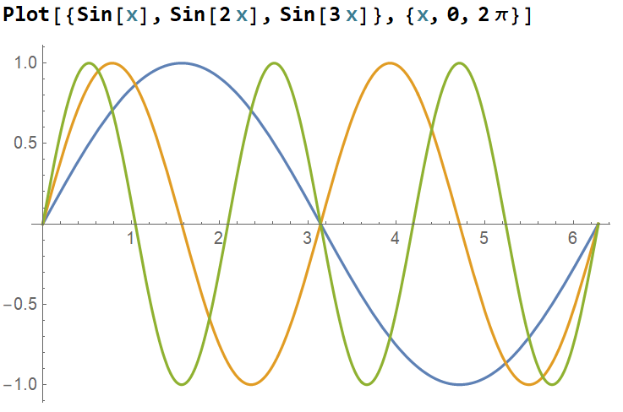

**Problem 23**

Approximately how many radians are in 90 degrees?

**Solution**

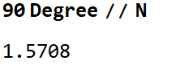

**Problem 24**

Evaluate 5!

**Solution**

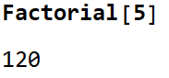

**Problem 25**

Evaluate Sin-1(1).

**Solution**

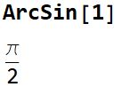

**Problem 26**

What is the square root of 3 + 4*i* ?

**Solution**

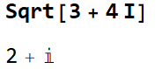

**Problem 27**

Expand (*x* + 1)3.

**Solution**

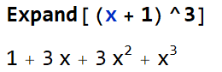

**Problem 28**

Plot the functions *y* = *x*2 and *y* = 2*x* + 10, -5, on the same axes.

**Solution**

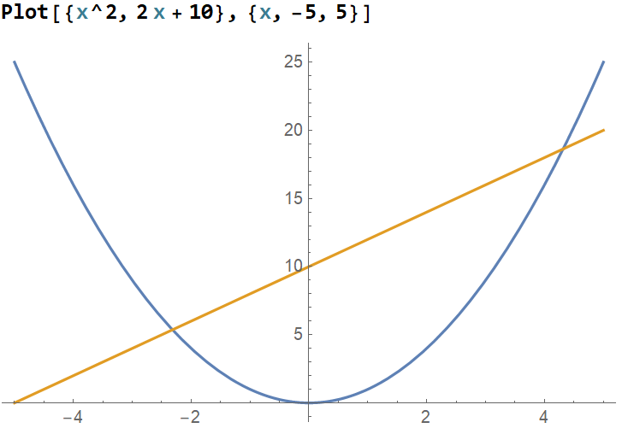

**Problem 29**

Sketch the graph of y = sin *x* , 0, labelling the axes and give the graph a heading.

**Solution**

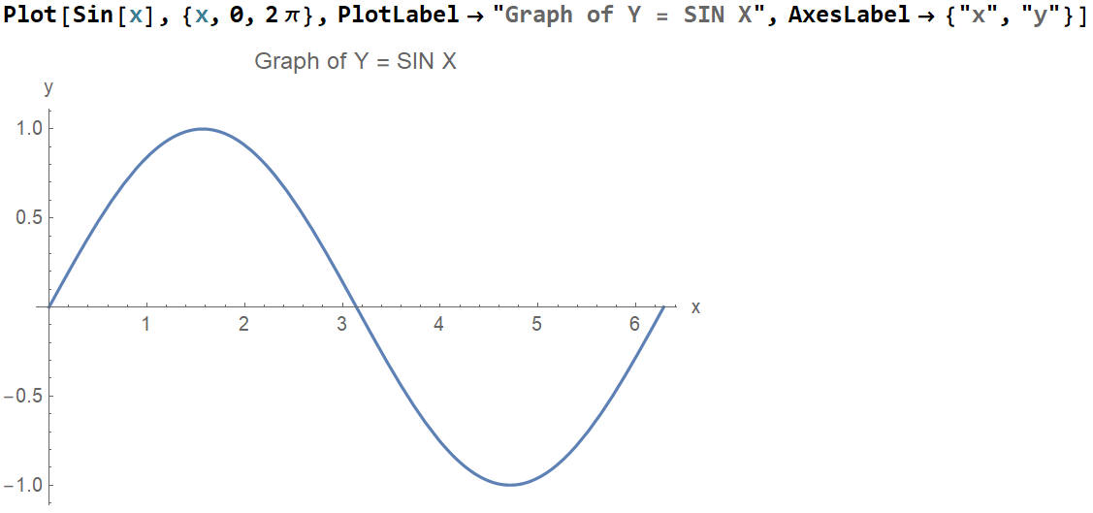

**Problem 30**

Sketch the cardioid *r* = 1 – cos and the circle *r* = 1 on the same axes.

**Solution**

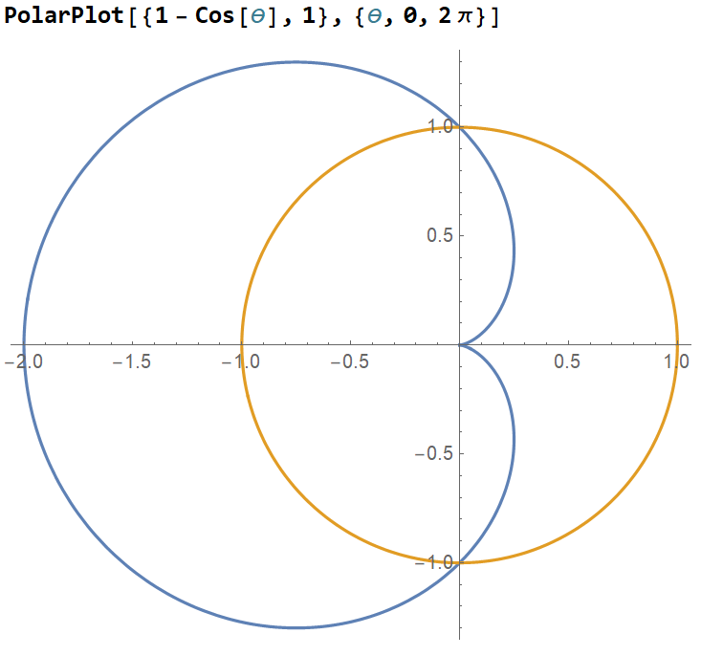

**Problem 31**

Solve the equation 7*x* + 3 = 3*x* + 8 for *x*.

**Solution**

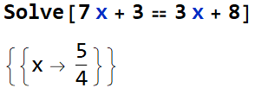

**Problem 32**

Solve the system of equations for *x* and *y*:

2*x* + 3*y* = 7

3*x* + 4*y* = 10

**Solution**

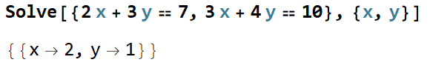

**Problem 33**

Solve the equation *x*4  - 16*x*3 + 61*x*2 – 22*x* – 12 = 0 exactly and numerically.

**Solution**

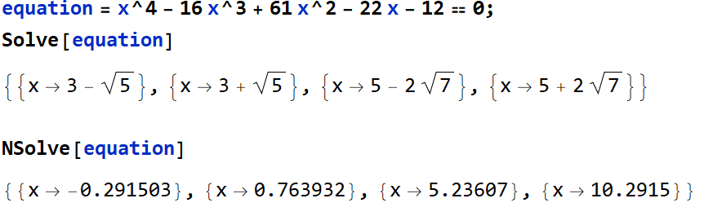

**Problem 34**

Simplify:



**Solution**

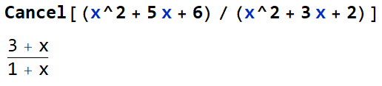

**Problem 35**

Express as one fraction:

 + 

**Solution**

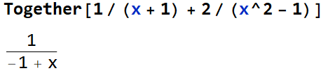

**Problem 36**

Express as partial fractions.

**Solution**

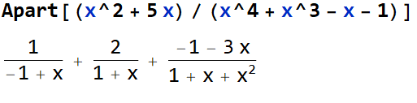

**Problem 37**

Simplify the trigonometric function:

.

**Solution**

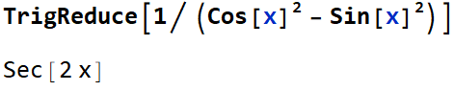

**Problem 38**

Compute .

**Solution**

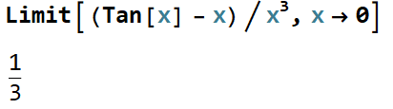

**Problem 39**

Evaluate the first, second and third derivative of .

**Solution**

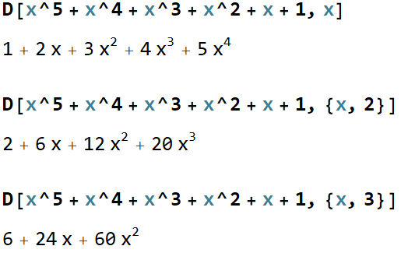

**Problem 40**

Compute the third derivative of tan *x* .

**Solution**

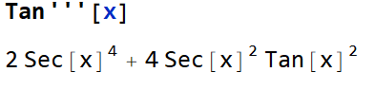

**Problem 41**

Compute *dx*.

**Solution**

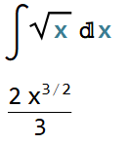

**Problem 42**

Evaluate numerically.

**Solution**

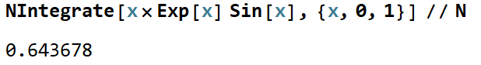

**Problem 43**

Solve the first order differential equation: = *x* + *y*.

**Solution**

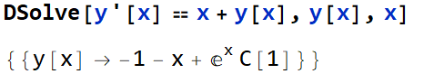

**Problem 44**

What is the mean, median and mode of the following data:

1, 2, 2, 3, 3, 3, 4, 4, 4, 4, 5, 5, 5, 5, 5.

**Solution**

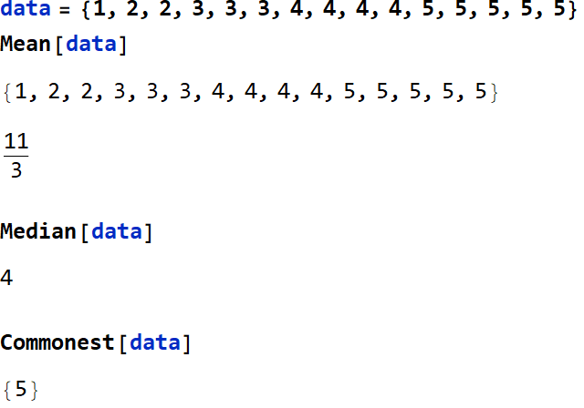

**Problem 45**

What is the variance, standard deviation and interquartile range of the following data:

1, 2, 2, 3, 3, 3, 4, 4, 4, 4, 5, 5, 5, 5, 5.

**Solution**



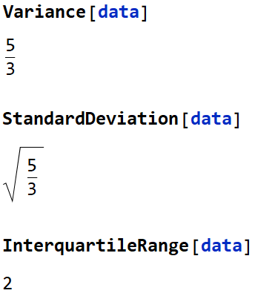

**Problem 46**

Create a table of the first five squares.

**Solution**

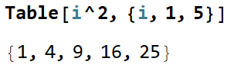

**Problem 47**

Calculate the determinant of the matrix .

**Solution**

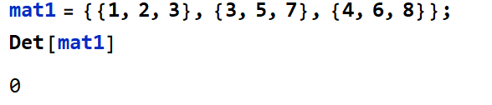

**Problem 48**

Sketch the graphs of *y* = sin *x* and *y* = cos *x*, 0.

**Solution**

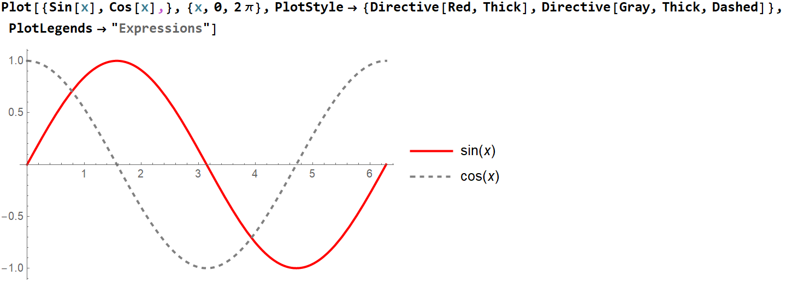

**Problem 49**

Find the root of the equation (sin *x*2) – cos *x* = 0 close to where x = .

**Solution**

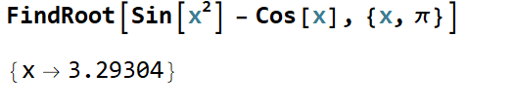

**Problem 50**

What does a caffeine molecule look like?

**Solution**

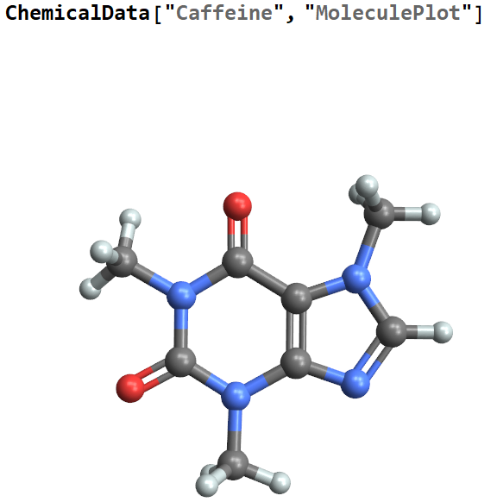



1, 3, 7 – trimethylpurine – 2, 6 – dione

**References**

Don, E., 2009. ‘Mathematica’, McGraw Hill.

Hastings, C., Mischo, K. & Morrison, M., 2015. ‘Hands-On Start to Wolfram Mathematica’, Wolfram Media.