ABCDE
1234
X
N
S

Developed by Gay West

gabrielle.west@nt.gov.au
Contents

1. Circular Table Cloth

Resources

Measurement – time, chance and data, circumference and area

Space – shapes and angles, location and position

2. Square Grid Table Cloth
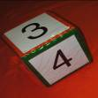

Resources

Number – Counting and Patterns, Calculating

Measurement – Area and Perimeter

Space, Graphs and Algebra – Location, data and Lines

3. Tea Towels and Face Washers

4. Beach and Bath Towels

5. Rectangular Table Cloth

Number

6. Regular Dot Table Cloth

Algebra

[For more details contact Gay West on 08 8999 3778 or gabrielle.west@nt.gov.au]

Making Maths Marvellous with Manchester

1. Circular Table Cloths have a variety of uses in the classroom. They can become a magic story carpet or story ring; a dance or rhyme circle; they are an excellent behaviour management device as all students have to sit around the circle; they make it easy to display an activity or game, or for turn taking.

In Mathematics, particularly they can become a useful tool for engaging students in a variety of learning experiences. Number is interwoven in the Measurement, Chance and Data and Space activities detailed below.

Resources:

- One circular table cloth (180cm diameter is a good size)
- Iron-on hemming tape attached in the centre and at the 4 quarter points on the edge on both sides
- 12 paper plates with the numbers 1 to 12 (hours) on one side and 5 to 60 (minutes) on the other
- 12 pegs & number cards can be used instead of paper plates
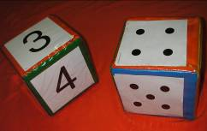
- Variety of dice (the large soft dice work well for activities,
Jumbo Pocket Dice – Mimosa/McGraw Hill Catalogue)
- Metre ruler and normal ruler, or two pieces of ribbon or tape
- Two sets of cards – hour cards (1-12), minute cards
(minutes to, past, quarter to and past, half past)
- Days of the week cards
- Months of the year and season cards
- Stopwatch
- Thick wool, string, tape, rope or colourful elastic loops
- Daily event cards – breakfast, lunch, bed time, swimming time, etc
- Glossary, wall chart, mobiles, flash cards with all the ‘time’ words
- Paper plates or cards for angles – 0, 30, 60, 90, 120, . . . 330, 360; 45, 135, 225, 315.
- Paper plates or cards for the compass points – N, S, E, W, NW, NE, SW, SE, NNW etc
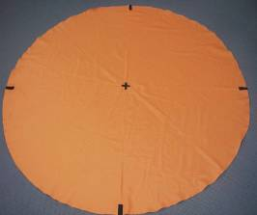
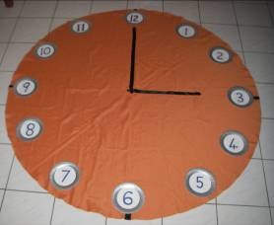
Measurement
It is vitally important that any new ‘time’ or ‘number’ words are printed onto charts or flash cards during the investigation and learning of these concepts.

Time

- Construct the Clock – use the numbered paper plates to count to 12 and back from 12, one student can physically walk around the clock taking one step to each number while the class claps and counts. Introduce the concept of clockwise and anticlockwise.

- Clock Numbers – say all the odd or even numbers; find the number after 3, before 7, opposite 9 or 2, two more or two less than 8, between 3 and 5; find the number between 6 and 9, that is odd.

- Counting with the Clock – by 1s, 2 s miss a number or every second number, 3 s miss two numbers etc, paper plates or cards can be turned over so that only the multiples of these numbers remain.

- A student sits with their legs outstretched and toes pointed to the 12:
Show me a full turn. Where do you end up?
Show me a half a turn, a quarter of a turn.
How many halves, quarters in a full turn?

- Use two students sitting back to back to make the time. For o’clocks, one student has their legs outstretched and toes pointed to 12 (minute hand), the other tucks in their legs (hour hand) while their knees point to the hour. (For upper classes, a metre ruler and a 30cm ruler or ribbons can be used for the minute and hour hands.)

- After the o’clocks, begin with the half pasts noting the legs (minute hand) swing ½ way round with the toes pointing to 6, while the knees (hour hand) move half way between the two hours, look at real clocks to reinforce this. Next quarter pasts and then quarter to s, moving onto 5 minute time intervals and last the individual minutes past and to the hour.

- Make the Time Game – use two sets of coloured cards, one set has the hours 1 to 12 (13 to 23 for 24 hr time) and the other set has a variety of minutes to and past, quarter to, quarter past and half past. Shuffle the two decks and students have to select an hour and a minute card and scramble to make that time (either with their legs or rulers). A stopwatch could be used to time them and find the champion pair of ‘Time Makers’. Discuss all the ways of saying one time eg 2:45 could be 45 mins past 2, quarter to 3, 14:45. Who can list the most? (Look at creative ways of saying that time, list these ¾ past 2, 1¼ hours to 4, 105 mins past 1, 2 hours past 12:45 etc.)
- What’s my past Time/ What’s my future Time? – Students
make a time, say 5 past 7. What was the time 20 minutes
ago? or What will the time be in 20 minutes? Students can
step clockwise or anticlockwise counting aloud in fives, say
5, 10, 15, 20, say aloud the past or future time, quarter to 7
or 7:25. Move onto more complex calculations of hours
and minutes, difference between certain times but get the
students to physically model this, clap and say aloud etc.

- Time of the Day Game – have a set of cards with
different daily events written on them, eg. breakfast,
lunch, going to bed, library time, going home time etc.
Students select a card, read out the event then walk
around the clock and stand at the correct hour.
Discuss different event times for different families.

- Seasons of the Year – place the seasons around the edge, one in each quarter, line up the correct months for each season and discuss the cyclical nature of each passing year. This can be related to the NT ‘seasons’ like ‘the wet’ and ‘the dry’, the burn off time and the cyclone time and the special cultural/indigenous times of the year. Months can be said out loud in a singsong fashion while a student steps around the circle. (Days of the week can also be placed around the circle and learnt in a similar way.)

- Counting by Fives on the Clock – the minutes can be written on the back of each hour plate eg 1-5, 2-10 ….. 12-60. Turn them all over and sit around the clock to practice counting forwards and backwards by fives, then say the five times tables (multiplication and division) while looking at the numbers.

- Turn the plates over to show the numbers 1 to 12, turn over the 1 to reveal ‘5’ minutes, now roll two dice, add them up eg 3 + 4 = 7, sing out what number will be on the other side of the plate, 35. It is good to back this up on the 100 grid – colour all the multiples of 5.

N
S
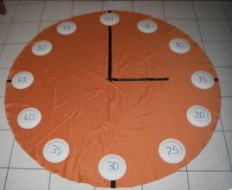
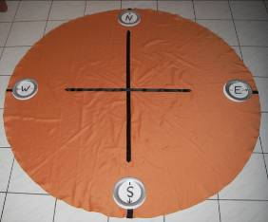
Chance and Data

- Chance and Data with the Clock – Use the game above to find how many rolls it takes to turn over every paper plate to show the minutes? Students can take it in turn to roll the two dice while another student can keep track of the number of rolls using tally marks. This activity can be repeated by pairs of students and the results can be discussed. What is the lowest/highest number of rolls recorded? What is the middle number? What would be about the average number of rolls required? What is most likely to occur? Do some combinations come up more often? etc.

- The game can be reversed by having all the minute sides facing up, 5 to 60, and when the dice are rolled add them up and say what number divided by 5 will give that answer, sing out what will be on the other side, eg. 2 + 4 = 6, then 30 divided by 5 will give me 6.

- Knock Out Around the Clock – Student A stands on the 3, Student B stands on the 9, another student rolls the die, say a 5 is rolled, Student A steps 5 numbers clockwise as the class claps and counts, dice is rolled again, say a 3 is rolled, Student B moves clockwise 3 numbers as the class claps and counts. The object of the game is to catch up to or overtake the other person, then they are out (they become the die roller) and a new student takes on the winner and the game begins again. Who can stay in the longest? Does anyone get out on the first roll?

- Keep a tally of the number of rolls for each game. What is the lowest score? (1roll – when you roll a 6) What is the highest score? What is the middle score? What is most likely to occur? [You can play the game anticlockwise, roll two dice and use the difference, use a pack of cards 1 to 6’s, or draw two cards and find the difference, use dominoes in a bag – difference between each side etc) Think of some more chance games to investigate.

Circumference and Area

- Investigation of circle features and measurements,
measuring and comparing the radius, diameter, chords
and circumference of the tablecloth using informal
then formal units, later using the various formulae.

- Circular table cloth can be ‘traced’ onto the large, square,
grid tablecloth, then students can find the area by counting
π
the square units, then using the formulae.

- Use of hour and minute hands to pose questions involving
circumference, area and rates involving lots of conversion
between units of measurement, eg. find the distance
travelled by the tip of the hour and minute hand in an
hour/day/year etc.

- Find hour/minute hand speed (mm, cm, m, km per hour).
How long does it take for each hand to travel a metre or km?
Find the area swept by the hands in a quarter/half or full hour etc.

Space

Shapes and Angles

- Clock Face Shapes – Once the clock numbers are in place, a student can sit at each number. What shapes are created when a strand of coloured wool (or elastic loop) is used to join up the numbers 12 – 3 – 6 – 9 – 12 ? Encourage the students to visualize and guess before proceeding. When the square is made, ask, Why is a square a square? Discuss all the features, eg. equal sides, 4 right angles. What happens when 1 – 4 – 7 – 10 – 1are joined up? I get another square! Can I make others?

- Using the same process, join up 12 – 4 – 8 – 12 (equilateral triangle). How can I make some others? Others include 12 – 2 – 4 – 6 – 8 – 10 – 12 (regular hexagon). Join all the numbers to form a regular dodecagon, 12 sided shape.

- Making Stars – (based on the Maths300 Game ‘Hunting for Stars’) join up 12 – 4 – 8 – 12 then a second triangle from 2 – 6 – 10 – 2 and so on. . . Join up every 5th number, every 7th number etc. Find as many stars or interesting shapes as possible, copy and colour.

- Investigate the angles – in all the activities above, the students can visualize, estimate, measure and calculate the related angles. Find the angles between the hands for 1 o’clock, 2 o’clock, etc, for all the minutes past, half and quarter pasts. At what times do the hands cross each other? (tricky!) At what times are the hands 180 degrees apart? etc.

- Angle Paper Plates and Cards – the students can again use their legs to get the idea that an angle is the amount of turn. Swing around to make a full revolution which is divided up into 360 smaller parts called degrees. Show me half a turn, which is 180. Show me a quarter of a turn, 90 degrees or a right angle. Students can construct 360 degrees just as they did the clock face, turning over the plates and estimating the angles is a great way to visualize the angles. (The 3, 6, 9 and 12 time tables can be related here.)

- Geometry of a Circle – the parts of a circle can be investigated and labelled and using wool or tape, many proofs can be modeled, eg. triangle in the semicircle is right angled, the angle that an arc forms at the centre of a circle is twice the angle that arc subtends at the circumference. Coordinate points of a circle can also be investigated as can Trigonometrical Ratios – Sine, Cos and Tan.

Location and Position

- Compass Points/ Bearings – again the points of a compass are constructed on the cloth and related to the angles.

- Time Zones/ Longitude and Latitude – the earth (tablecloth) can be chopped up into 15 degree/ 1 hour intervals and this is very readily modelled on the cloth.
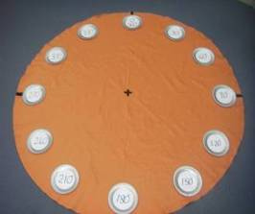
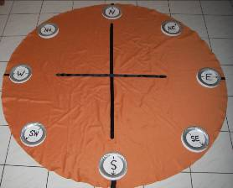

2. Square Grid Table Cloths

These types of table cloths are perfect for many Number, Space and Measurement activities.
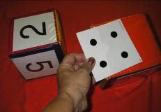
Resources:

- Square Grid Table Cloth (180 cm x 180 cm is a good size)
- Masking tape or fabric paint
- Variety of dice – the Jumbo Pocket Dice work well
- Counters, blocks, or other objects like teddy bears
- Masking tape, fabric paint, wool, string or tape
- Number cards to fit in each grid – 1 to 100 (or 101 to 200)
These can be coloured say blue on one side and yellow on the other for contrast.
- Variety of number cards – percentage (1-100%), decimals (.01-1, 0.1-10, etc)
- 100 Grid Activities and Ideas – lots in CMIT and associated books like the DENS Books 1 & 2 (Developing Efficient Number Strategies), and web sites like www.mathswire.com

Number

Counting and Patterns

100 grid activities
- ordering and counting the numbers
- counting forwards and backwards by 10 s first, on the decade eg 10, 20….90, 100, then off the decade eg 3, 13, . . . 83, 93 etc
- counting by 5’s forwards and backwards
- counting by other numbers starting with 2’s . . .
- whisper or rhythmic counting eg 1, 2, 3, 4, 5, 6, 7, 8, 9, . . . .
- look at even and odd numbers
- count by 20s or 25s
- make interesting patterns eg 1, 2, 4, 8, 16, . . . or starting at 3, 7, 11, 15, . . . or 2, 6, 8,12,14,. . Use subtraction too, eg start at 20, 17, 14, . . . .
- can do similar activities but use numbers between 101 and 200, percentages eg 1% to 100% or decimals eg .01 to 1 or 0.1 to 10

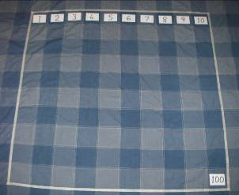
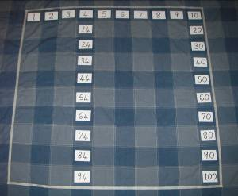
Calculating

100 grid activities
- Use for addition and subtraction eg 5 add 8 say 5 + 5 then 3 more, or 18 – 9 say 18 – 8 then take 1 more.
- Progress to two digit addition 23 + 15 say 23 + 10 then 5 more, or 23 – 15 say 23-10 then take 3 then 2 more. Find out all the different ways of working it out.
- ‘Friends to 100’, roll two dice and make a number, eg. 5 and 3 makes 53, count by 10 s to 93 then 7 more, so the friends are 53 and 47. Reverse, by rolling two dice and making a number and taking it away from 100, then you also find the two friends (adjust these activities to 20 or 50 for lower level students).
- Roll two dice and make a number, roll again to make another number and add it to the first, see who can get closest to 100 in the smallest number of rolls. Reverse this by starting at 100 and taking away the numbers, see who can get closest to zero.
- Remove all the numbers and use the blank 10 x 10 grid, roll two dice, say 3 and 4, make a 3 by 4 array with counters, blocks or other markers, eg. teddy bears, then count the number of objects = 12.
- Practise times tables by rolling one die and multiplying the number by 3 every time, roll 2 dice and add them up then multiply by 3, count the array objects.
- How many arrays can you make using 12 objects? = 3 x 4 = 4 x 3 = 2 x 6 = 6 x 2 (12 by 1 as well)
- Place 12 counters in rows of 5 and find how many rows (2) with how many counters left over, 2, so 12 divided by 2 is 5 remainder 2. Try some other numbers.
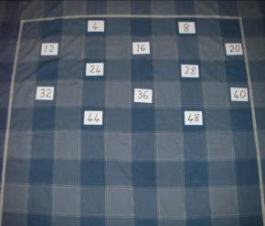
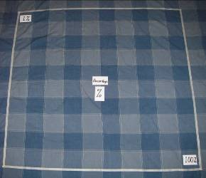

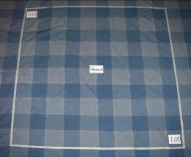
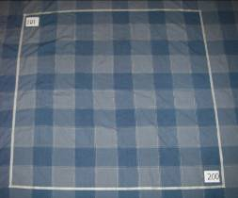
Measurement

Area and Perimeter

- Remove all the numbers and use a blank 10 x 10 grid for area and perimeter activities.
- Make an array by rolling 2 dice, eg. 4 and 6, place counters in a 4 x 6 array and count how many, 24, then find the perimeter by counting initially, 20.
- Make up games using this method, eg. take it in turns to make an array and keep your progressive score, as soon as a player can not fit an array on the cloth then the game stops and the one with the highest score wins.
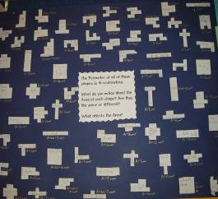
- Add the two scores, how many squares are
uncovered? The three values should add to 100.
- Open questions on Area and Perimeter:
P = 16, What could the area be? How many
different shapes can you make? What are their
features and names?
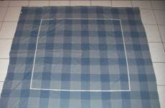
P = 16

A = ?

Shapes
are . . . .

Space, Graphs and Algebra

Location, data and Lines

- Two strips of masking tape are used to make an X and a Y axis.
- Place points on the Cartesian Plane, stressing the X coordinate comes first in the ordered pair, counters or other objects can be used.
- Make many shapes using coordinates, practise directions, eg. 4 to the left, 5 down.
- Calculate and draw equations of a line from patterns, eg. the 3 times table.
- Make more complex patterns and algebraic equations and ‘draw’ the line using wool, string or tape, counters, move up or down and see how the equation changes.
- Use for making bar graphs with original data from the students investigations.
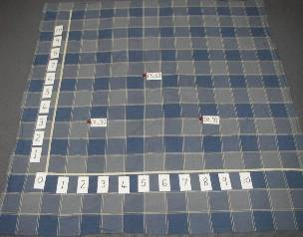

DATA
3. Tea Towels and Face Washers

- Grid tea towels can be used similarly to the table cloth especially for arrays.
- Use dice, cards, dominoes, counters, blocks, tiles, tiny animals or squares of cardboard. Find different ways of putting say 12 objects into arrays – 1x12, 2x6, 3x4, 4x3, 6x2,12x1.
- They are useful for area investigations, by covering squares with cards or tiles.
- The large check tea towels can be used as a template for a calendar jigsaw.
- Many tea towels are just right for numbers stories: Legs on the dogs, horns on the cows
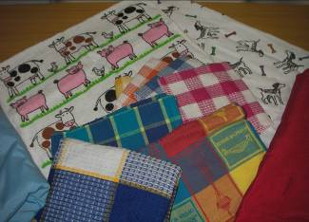
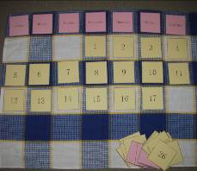

Tell me as many number stories as you can about this tea towel . . . .

Calendar investigations

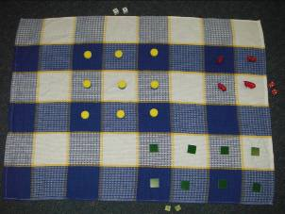
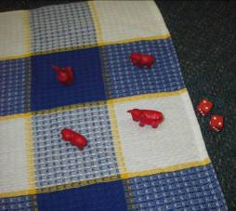

Arrays –
2 x 2 make
3 x 3 and
2 x 4 count
3 x 4

6 squares – how many ways?

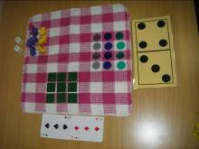
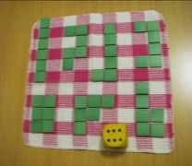

Number Charts
- Grid tea towels become excellent Number Charts (Maths300) and can move from the very simple to the complex (starting with counters, moving to numbers, fractions, decimals, percentages, then pronumerals like x & y). All the operations can be used +, -, x, /.
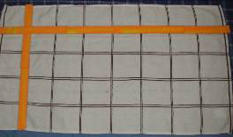
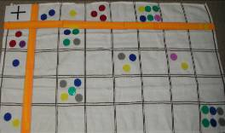

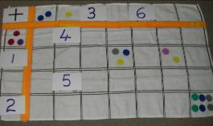
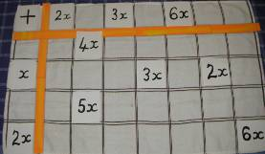

4. Beach and Bath Towels

- Towels with grids, circles or other shapes can be used to make and investigate arrays and for counting as above. Some are colourful and geometrical to help engage students.
- Use larger objects or paper plates to demonstrate arrays – play ‘Fill in the grids” using dice, cards, spinners or dominoes.
- For the towel below, counting by 5s would be an excellent activity, then use for multiplication and division without and with remainders.
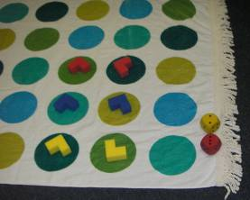
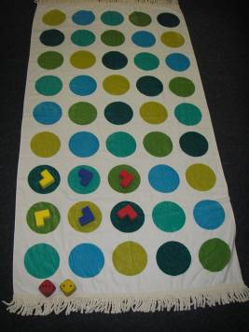
5. Rectangular Table Cloths
Use MABs, blocks or 10 frames to describe my number
Write some addition and substraction stories for my number

Write some multiplication and division sentences for my number

Show some patterns that will get to my number

Number is ……..
This type of cloth can be used across the curriculum
to display topics or showcase results.

Number

- Think Mats or ‘What’s my Question?’ activities
can be done by first marking out the table cloth
with a space in the centre and 4 quadrants, then
place a number in the centre eg 18.
- Students have to show in a variety of ways how to make 18, using bundles of sticks, pencils, MABs, ten frames, dice, calculator, other objects, place value cards, make up word problems with an answer of 18, make up addition, subtraction, multiplication, division, squaring and square roots, make number sentences using brackets etc.
- There are so many ways to use this activity in all areas of maths – space, measurement, chance and data, algebra. ( 18 metres, 18 square units,18 Litres etc)
- A series of 10 frames can be drawn on the cloth and all the 10 frame activities can be modelled for a large group of students (Count Me in Too related books, eg. DENS 1 & 2).
My Number
Stories
Symbols
Pictures
Real Things
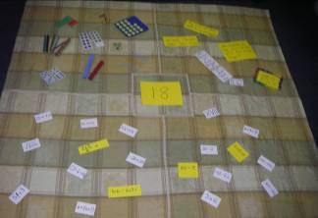
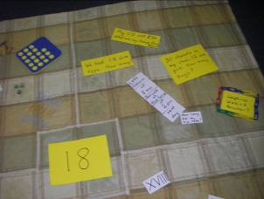

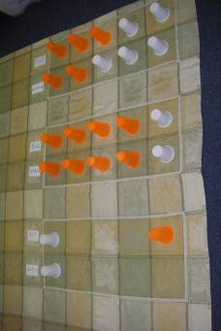
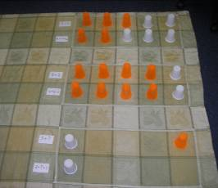
10

F
R
A
M
E
S

6. Regular Dot Table Cloths

Algebra

- Make 4 quadrants using tape to make the X and Y axes, this can be used for more complex linear and quadratic equations, noting the key features and points.
- Move the lines and curves up and down and note the changes in the intercept, change the coefficients and notice the change in the slope, note the shape differences.
x
y
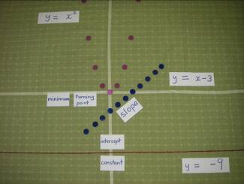

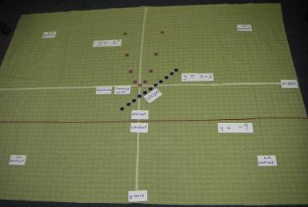

Slope = rise/run

General Comments from Teachers:

“I now look at tablecloths, tea towels and towels in a whole new light.”

Comments for Kate McMaster
(Kate was located at Bonya School a remote indigenous school in Central Australia)

“A large towel with polka dots is our 'Times Table towel', which kids sit around when they need to use concrete materials to work out multiplication or division problems. I had Sarah (year 4) working out 24 / ? = 8 at one end of the towel and Caine (Year 2) working out 2 x 6 = 12 at the other.

I also used a large checked table cloth on each table and little coloured square tiles for area of rectangles and perimeter activities. It meant that the group could sit together at their table and make different arrays all over it then do the maths to go with it.

All kids have checkered face cloths for arrays that they keep in their tray and can get out whenever they need it - we also used the face cloths for picture graphs (The Very Hungry caterpillar) which the older students then transferred onto a pie graph. I have worked out a way to do the same lesson for maths with all the kids from Pre to 9, but targeting different outcomes.”

Pictures and video clips available at:
http://picasaweb.google.com.au/BracegirdleKym/PhotosFromMathsMeet2009#

More useful files on my wikispace:

