Chance Connections

Dr Jennifer Way

University of Sydney
The purpose of this paper is to provide an overview of the key concepts in Chance and Probability for primary and early secondary students, how these ideas develop and the ways in which they connect with other concepts and ideas in mathematics. The intention is to provide teachers with some insight into the nature of probability reasoning and provide some guidance for devising productive learning experiences for their students. It is structured around addressing the following questions: What is probability? How does probability thinking develop? How does probability connect with other mathematics? What are the key teaching points? What types of learning experiences should be planned? How can technology support probability learning?

What is probability?
In general, probability is defined as the quantification of chance, and requires the recognition of randomness and the application of proportional thinking. More specifically, the integration of a range of concepts is required for appropriate probability reasoning. The following list not only defines key vocabulary, but also presents the key ideas that should be the focus of teaching in primary and early secondary schools.

The key concepts and connections between them
- Randomness or chance means that outcomes cannot be pre-determined.
Probability reasoning requires co-ordinating understandings of randomness and proportional thinking.
- Probability is an assigned value (actually an estimate) given to the likelihood of a particular outcome occurring in a random situation. It is calculated by forming a part-whole fraction; the numerator being the number of times an outcome can occur and the denominator being the total number of possible outcomes.
- Sample space is the complete set of possible outcomes. For example, there are four possible outcomes for tossing two coins – HH, TT HT, TH. Therefore, there is a 50% probability of a head and tail combination, but only a 25% chance of tossing each of the double outcomes.
- A random generator is a device or situation that produces random outcomes (eg. rolling a dice, drawing a card from pack).
- Impossible events have a probability of 0. Certain events have a probability of 1. Therefore, all other probabilities lie between 0 and 1, so are expressed as fractions less than one.
- Likelihood can be compared and ordered from least likely to most likely.
- Equal likelihood means that the outcomes have the same chance of occurring eg. Flipping a head or a tail on a coin.
- Different sample spaces and random generators can have the same mathematical structure and therefore be equivalent.
- Independent events means that each time we generate an outcome, it is independent of all other outcomes. Eg. Each time a coin is tossed there is a 50% chance that the outcome is a head, no matter how many tails have already occurred.

How does probability thinking develop?
There is substantial evidence that the understanding of probability is strongly linked to cognitive development. While much of this development is intuitive (Fischbein, 1975; Way, 2003) there is also evidence that instruction can assist with the learning of probability (For example; Fischbein, 1975; Green, 1989; Jones, Langrall, Thornton & Mogill, 1999). Unfortunately this research has not translated into a framework that is easily accessible to teachers, but the essence of the development is presented in this paper (Table 1). The developmental framework outlined here draws primarily on the research Way (1997, 1998, 2003), though there is considerable correlation with the findings of Jones and colleagues (1997, 1999), and Watson and colleagues (1994, 1995, 1997).

Table 1: Phases of development for probability thinking
Phase of development | Characteristics of thinking
Phase 1  (Early years) | Limited probability judgements. Idiosyncratic reasons.  No coherent use of relevant elements  Minimal understanding of randomness  Reliance on visual comparison  Can’t order likelihood
Phase 2  (Early to Mid primary) | Increased accuracy of judgements  Recognition of randomness, but sometimes ignored  Inconsistent reasoning  Beginning to use numbers to describe sample space  Concepts present in isolation
Phase 3  (Mid to late primary) | More systematic approaches to examining the situation  Recognition of sample space  Uses numbers informally to express probability  Several concepts applied, in isolation or in linear fashion  Ordering through visual comparison or estimation  Addition and subtraction strategies for comparisons  Concepts of equal likelihood and impossibility stabilised
Phase 4  Late primary early secondary | Complete analysis of sample space  Assigns numerical probabilities in a range of basic situations  Integrated understanding of relationships  Numerical comparison made  Doubling and halving strategies  Proportional thinking
To better illustrate the progression of children’s thinking across these phases of development, three tasks have been selected and examples of the types of student explanations for each phase are presented in Tables 2, 3 and 4.

Table 2: Task 1 examples of phases of probability thinking
Task 1 description | Responses for each phase of development in thinking
4 blocks are placed in box, 3 of one colour and one of another colour.  Which colour is more likely to pulled out? Why? | Phase 1: “Yellow. Because it’s a good colour. Sometimes it’s on flowers.  Phase 2: “There’s more blue in there”, but in another instance, “Red, because three blues have already come out.”  Phase 3: “There’s more red than green so there’s more chance of getting red”.  Phase 4: “There’s three blue and only one red. It’s just chance, but there’s more chance to get one of the blue than the one red.’
Table 3: Task 2 examples of phases of probability thinking
Task 2 description | Response for each phase of development in thinking
Two spinners (used in a racing car game) are discussed. One has equal portions of red, yellow, blue & green. The other has these four colours in the ratio 4:2:1:1  The children were then asked to put some blocks in the box to create equivalent random generators for the games. | Phase 1: Spinner A. They look the same. (Put one of each colour in the box). Spinner B: It’s got bigger red. (Put a handful of red only in the box)  Phase 2: Spinner A. “Each of them have a quarter of the colour (Put equal amounts in the box). Spinner B: Covered each sector on the spinner with matching coloured blocks and put these into the box.  Phase 3: Spinner A: To make it equal, I’d put two of each colour. It could be three or however many you wanted, as long as there’’s an equal number of each”. Spinner B: Not necessarily certain to lose because if the spinner stops on the smallest part more than the other colours it could still win.  Phase 4: Spinner B: If I put in one of each for blue and green – they’re only small. That yellow part is twice the size, so two in there, and the red is four times the size of that blue part, so I put in four.
Table 4: Task 3 examples of phases of probability thinking
Task 3 description | Responses for each phase of development in thinking
Two jars of teddy-bear counters containing a visible mixture of red and yellow are shown. (The bears are taken out and lined up in front of the jars).  Game 1  Jar 1: 2 red, 4 yellow  Jar 2: 4 red, 8 yellow  Game 2  Jar 1: 3 red, 5 yellow  Jar 2: 3 red, 7 yellow  Which jar would give the better chance of pulling out a red bear? | Phase 1: The second one looks easier.  Phase 2: Game 2: Jar 1. It doesn’’t have as many yellow. There’s both three red.  Phase 3: Game 1: There’s four more yellow bears than red bears in Jar 2, but there’s only two more yellow bears than red in Jar 1.  Phase 4: Game 1: They’re both the same. That’s half of four, and that’s half of eight, so they’re the same [proportion]. And This jar is one third [ratio of red to yellow] and this jar is one quarter.

How does probability connect with other mathematics?
Probability concepts develop in conjunction with other mathematical ideas and probability reasoning depends upon their development. Though not an exhaustive analysis, Table 5 provides an outline of the connections between some key skills in the topics of whole number, fractions, chance and data.

Table 5: Outline of alignment of mathematics skills with chance
Whole number | Fractions | Chance | Data
Counting | Halves and quarters | Lack of randomness concept | Classifying and counting
Adding and subtracting | Part whole thinking, sharing, re-unitising | Initial notions of randomness.  Visual and additive strategies for comparing | Initial data representations and comparisons
Multiplying and dividing | Fractions as numbers (positioned on a number line.  Equivalent fractions and operations | Connection of sample space to likelihood.  Ordering of likelihood. | Organization of data  Multiple representations.
Flexible multiplicative thinking | Proportional reasoning | Integration of concepts.  Multiplicative and ratio-based comparison strategies.  Positioning numerical probabilities on a number line | Descriptive statistics  Proportional representations  Importance of sample size

What are the key teaching points?
In the early years, children rely on visual comparisons and have little concept of randomness, so there is little value in experimental tasks such as drawing blocks out a box. However, informal experiences such as games with dice and spinners, where the sample space is visible, can help expose them to chance events. Young children also need support in beginning to consider a range of possibilities.
In early primary, some of the necessary concepts are forming but they tend to remain separated, so reasoning is quite inconsistent. As a consequence, assessments of the children’s progress will often give contradictory results. Plenty of opportunity for exploration of chance situations through experiment and data collection is needed. In this phase, students’ reliance on visual strategies decreases and the use of numbers to describe sample spaces and make comparisons increases. Discussions that expose and challenge the inconsistencies in the children’s strategies and thinking are critical to the development of more stable reasoning.
In mid to late primary some critical connections between concepts occur. As students begin to shift from additive to multiplicative thinking in their fractions work (such as finding equivalent fractions) they will be able to apply this to explain comparisons of likelihood and to calculate probabilities. Tasks that challenge students to order the likelihood of outcomes are beneficial at this time. Clarification of the concepts of certainty and impossibility should occur. Experimental tasks that require data collection provide an opportunity to engage with the notion of ‘the more data that’s collected, the more reliable your judgement will be’.
In late primary and early secondary proportional reasoning matures allowing students to quantify chance. Students are able to integrate the various elements of probability and understand the relationship between them well enough to provide well-reasoned explanations. During this development students need to engage in problem solving tasks that demand careful analysis of sample spaces. They also need opportunities to investigate chance situations through experimentation, data collection and data interpretation. The discrepancies between expected outcomes based on theoretical probability and the actual outcomes resulting from experiments must be confronted and resolved.
What types of learning experiences should be planned?
Three approaches, based on the models proposed by Jones (1977) that have proved useful for structuring learning experiences for children, are the social, experimental and theoretical approaches. Each of these provides a different perspective with which to view the meaning and description of probability in various contexts. An explanation of each approach follows, including some examples of activities that could be expanded into learning experiences.

Social probability
In everyday life we informally assess the likelihood of events based on past experience, evidence around us and a bit of reasoning and logic. Because much of this input is subjective, culturally based, misleading or misinterpreted, we often get it wrong! We tend to base our judgements on recent experiences or on knowledge of the current situation that could easily change. Beware: life is full of uncertainty. Even events we have great confidence in, like the sun rising each day, can be called into question under close scrutiny.
Usually, in informal social contexts, we use descriptive words to express the probability of an event, rather than numbers. For example: definitely, very unlikely, possible, very small chance, about even, no chance, will never happen. Trying to compare the likelihood of different events, or to place a numerical value on our judgement, requires us to think more carefully about the meaning of our chosen words.

Example 1 – stories (Early years)
When reading or telling a story to young children, pause to ask them what they think might happen next. Encourage them to consider a range of possibilities and discuss which of the proposed outcomes might be most likely to happen.
Example 2 – word and event sequencing (Mid to late primary, early secondary)
Think of a word to describe the chance of the following events happening and place them in order from least likely to most likely (or locate them on a 0 to 1 number line):
- The sun rising in the west tomorrow
- The likelihood of rain tonight
- Two people in this room having the same birthday
- You winning a holiday in Fiji in February
- The probability of a female walking in the door in a few minutes
This is best begun as a small group activity and discussion and debate encouraged. The older the students, the more sophisticated (and philosophical) the discussion becomes.
Some teachers may have difficulty in seeing the value of these types of activities, perhaps because there is no data collection or calculated probabilities, and so the tasks only seem vaguely mathematical. However, their educational value goes beyond developing mathematical vocabulary and is perhaps greater than for tasks like pulling blocks out of a bucket or rolling dice, because of their direct connection to everyday decision-making. Contemplating the changing variables in these situations is a worthy intellectual exercise. Understanding the complexity and uncertainty of real situations is fundamental to the study and application of probability. At a more advanced level, incredibly complex probability formulae are used to account for variables and understand natural chaotic phenomenon such as weather, to calculate risk in health matters, create mathematical models of complex engineering situations and to predict financial futures.

Theoretical probability
If we have complete information about a chance situation, including the sample space and the nature of the random generator, we can calculate the expected probability for each possible outcome. For example, when rolling a typical, fair dice, if we have sufficient experience, we accept that each outcome is equally likely. Another way to express this is say that the random generator is symmetrical. The number we use to quantify a probability is usually a ‘part-whole’ fraction, such as ‘there is a 1 chance in 6 of rolling a 5, expressed as ¹/₆.
To calculate a theoretical probability it is essential to have a complete understanding of the sample space. Sometimes the necessary information is not immediately apparent and some analysis has to be done to work out all the possibilities. For example, when rolling two dice and adding, it is easy to make a list of the possible totals but this does not give a complete picture of the sample space. It is necessary to work out how many different ways it is possible to create each total. Through this analysis we discover that some outcomes are more likely than others (see Table 6). For example, there are six ways to roll a total of 7, but only two ways to roll a 3.
It is important to remember that the calculated probability is only theoretical, so if we were to test the theory with a relatively small number of trials, we should not expect the outcomes to match the calculated probability. For example, the calculated probability for rolling a 5 is 1 in 6, so for example, for 36 rolls the theoretical expectation would for the 5 to occur 6 times. In reality, if we made 36 rolls the 5 could occur from 0 to 36 times. However, if we made thousands of rolls we may find that eventually the probability does conform to the expected ¹/₆.
Calculating the theoretical probability for an event sets up an expectation for a particular set of results, but in reality we often see variation in the results, caused by randomness (Watson, 2007). This mismatch of probabilities (theoretical and experimental) can lead to confusion for students who have not yet realised the discrepancies that can occur between ‘short-run’ and ‘long-run’ data sets.

Activity Example 1 – informal ordering (mid primary)
What colour am I most likely to draw out of a bag containing 4 red, 1 blue, 10 green? What colour is least likely? Why?

Activity Example 1 – calculating probabilities (late primary)
What is the likelihood of rolling a 3 on a twelve-sided dice? What is the likelihood of rolling an odd number?

Experimental probability
This approach is most useful when we don’t have enough information about a random situation, so have to generate some data to help us estimate the probability of each outcome. So we conduct trials and record the outcomes until we have enough data to make probability estimates with reasonable confidence. The issue of collecting sufficient data to give an accurate picture of the random situation is critical in experimental approach.

Activity 1: Plastic cup tossing (mid to late primary)
What are the different positions a plastic cup can land in? Is each of these positions equally likely to occur? In small groups, toss a plastic cup 20 times and record the number of times it lands in each position. Write three statements about your findings then compare your statements with other group’s findings.
Collate the class results, find the totals for each position and perhaps convert to percentages. How confident are you that the same numbers would result from another set or trials? How many trials are enough to be sure?

Activity 2: Mystery bag (late primary, early secondary)
Without looking in the bag, make 10 draws and record the outcomes (replace the tile after each draw and shake the bag). Discuss the possible contents of the bag. Without looking in the bag, repeat this process for another 10 draws. Refine your prediction of the bag’s contents: if there are 10 tiles in the bag – predict the number of each colour. Now you may look in the bag.
This works well as a small group activity, with each group having the same bag contents (but don’t tell them this). Often, at least one group will get a very different set of results and this can lead to some worthwhile discussion about randomness and the lack of reliability of small data sets.

Connecting the three approaches
Using a problem-solving task can provide a valuable opportunity to connect all three approaches. The social approach can be useful as an initial introduction to the task context. The experimental approach allows some exploration of the sample space and often reveals potential ‘patterns’ in data or raises questions that require closer examination of the context. This leads into the systematic analysis of the sample space, which provides the information needed to determine actual theoretical probabilities. An example, suitable for late primary to early secondary, follows.

The Thirty-six Game
Rules: Role two dice and add the two numbers. If the total is 5, 6, 7 or 8 the teacher gets a point. If the total is any other number the class gets a point. Whoever has the most points after 36 rolls wins the game.
Is this a fair game? Why or why not? If it is fair, how can you prove it? If it is not fair, how can the rules by changed to make it fair?
Social approach: Begin by playing the game as a class a few times and see who wins. Discuss opinions about the games fairness. A common response is to say the class has an unfair advantage because they have totals seven totals available for point scoring (2,3,4,9,10,11,12) and the teacher only has four opportunities. However, the teacher is likely to have won at least one of the games, so questions should arise about this reasoning.
Experimental approach: Divide the class into small groups to roll a pair of dice 36 times and record each total (Using a multiple of 6 provides a convenient number for forming fractions or discussing expectations). Organise the results into a table and create a graph. Listing the totals along an axis in either ascending or descending order will produce the most informative display. Is there enough information to be sure? Collate group results and discuss the data in relation to the problem. Why is the graph shaped this way (bell curve)?
Theoretical approach: Record all the possible combinations that produce each total (as in Table 6). Count how many ways there are to get each total and work out the probability for each total. Complete the problem solution.
Table 6: All the combinations for adding two dice, with the ‘teachers’ numbers shaded
 | 1 | 2 | 3 | 4 | 5 | 6
1 | 2 | 3 | 4 | 5 | 6 | 7
2 | 3 | 4 | 5 | 6 | 7 | 8
3 | 4 | 5 | 6 | 7 | 8 | 9
4 | 5 | 6 | 7 | 8 | 9 | 10
5 | 6 | 7 | 8 | 9 | 10 | 11
6 | 7 | 8 | 9 | 10 | 11 | 12

The teacher actually has 20 (out of 36) opportunities to win, while the class only has 16 chances. Students with sufficient understanding of fractions could form the probabilities for each total. For example, the probability of the total being 2 is ¹/₃₆ and the probability of the total being 3 is ¹/_{18.}
As an extension, the knowledge of the probabilities for each total could be applied to develop strategies for winning the ‘Number line game’. (This game also provides an alternate starting point for the series of activities described above).
Number line game: On a number line from 2 to 12, distribute 20 counters in whatever positions you like. You can place as many or as few as you like on each number. Roll two dice and use the total to tell you which counter to remove from your number line (remove only one at a time). Race against someone else – each person with their own number line and taking their own turn at rolling the dice. The first person to remove all the counters wins.

How can technology support probability learning?
Digital resources can provide learning opportunities that are very difficult to achieve through other materials, particular for exploring experimental probability situations.
Technology affords several significant advantages:
- Rapid generation large quantities of data;
- Multiple representations of data that are dynamically connected and so demonstrate relationships;
- Easy and accurate constructions of random generators; and in many cases,
- Feedback on ideas and trials.

Spinners: Advanced builder
As an example, one of a series of learning objects created by The Learning Federation* is described here, with some screen shots shown in Figures 1 and 2. In this digital resource students are able to quickly construct spinners with up to 12 sectors, using up to five colours. These spinners can then be tested using from 10 to 10 000 spins. The results are recorded in a table that displays both the theoretical probabilities and experimental results. As the numbers in the table change as the spins are rapidly completed, students can watch the corresponding graph grow.
The stated learning objectives for the resource are:
- Students explore the relationship between sample space and likelihood of outcomes.
- Students explore the difference between the information provided by short-run, medium-run and long-run data

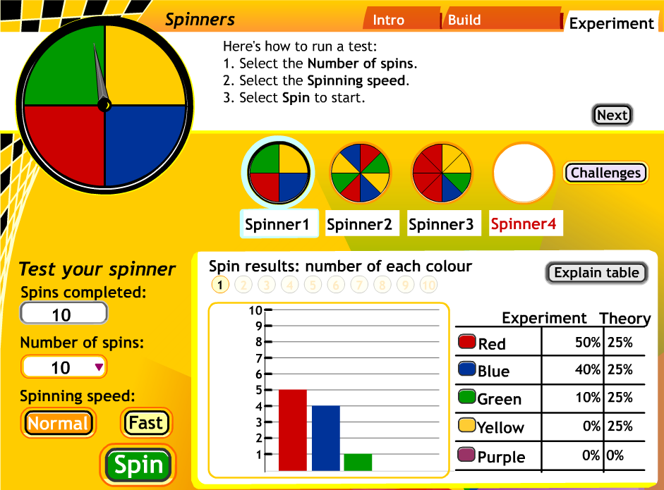
Figure 1. Spinners: Advanced builder – results for 10 trials.
Figure 1 shows the results for 10 spins of a spinner, in which each of the four colours is equally likely to occur. The graph and the table clearly show that the results do not conform to the theoretical probabilities. However, Figure 2 shows the results from 10 000 spins, which almost match the theoretical expectations.

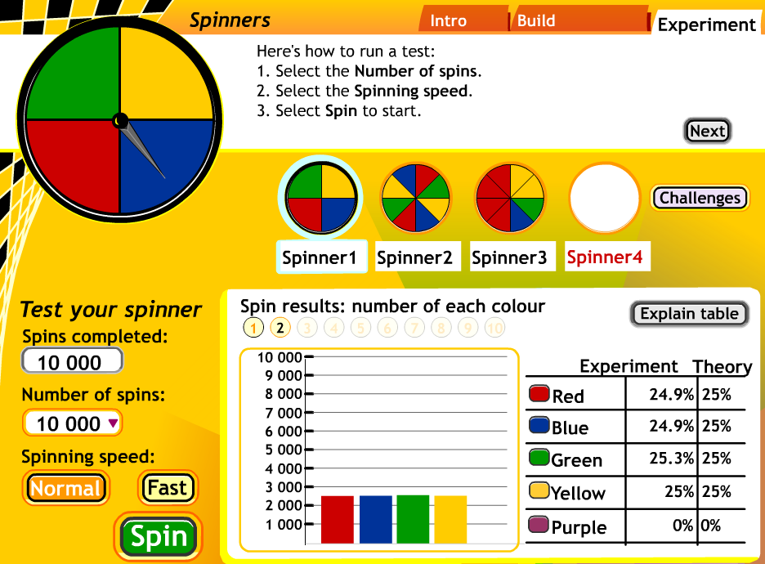
Figure 2. Spinners: Advanced builder – results for 10 00 trials.
Note: *The Learning Federation is a government-based organization producing digital resources for all the department of education in Australia and New Zealand. These resources are readily available to all primary and secondary schools.
For further information see http:// thelearningfederation.edu.au

Conclusion
Perhaps the most important ingredient for quality learning in probability is the teacher’s understanding of connections: connections between the necessary concepts, connections with other mathematical thinking and connections between the different approaches to understanding probability.

References
Jones, G. (1977). Effect of grade, I.Q., and embodiment on young children’s performances in probability. In F. Biddulph & K. Carr. (Eds.), People in mathematics education: Proceedings of the Twentieth Annual Conference of the Mathematics Education Research Group of Australasia (pp. 159–178). Rotorua, New Zealand: MERGA.
Jones, G., Langrall, C., Thornton, C. & Mogill, A. (1997). A framework for assessing and nurturing young children’s thinking in probability. Educational Studies in Mathematics, 32, 101–125.
Jones, G., Langrall, C., Thornton, C. & Mogill, A. (1999). Students’ probabilistic thinking and instruction. Journal for Research in Mathematics Education, 30 (5), 487–519.
Watson, J. (2007). The foundations of chance and data. Australian Primary Mathematics Classroom, 12 (1), 4–7.
Watson, J., & Collis, K. (1994). Multimodal functioning in understanding chance and data concepts. In J. da Ponte & J. Matos (Eds.), Proceedings of the Eighteenth International Conference for the Psychology of Mathematics Education (pp. 369-376). Lisbon, Portugal: Organising Committee of PME18.
Watson, J., Collis, K., & Moritz, J. (1995). The development of concepts associated with sampling in grades 3, 5, 7 and 9. Paper presented at the Annual Conference of the Australian Association for Research in Education, Hobart.
Watson, J., Collis, K., & Moritz, J. (1997). The development of chance measurement. Mathematics Education Research Journal, 9 (1), 60–82.
Way, J. (1997). Which jar gives the better chance?: A study of children’s decision making. In F. Biddulph & K. Carr. (Eds.), People in mathematics education: Proceedings of the Twentieth Annual Conference of the Mathematics Education Research Group of Australasia (pp. 568–575). Rotorua, New Zealand: MERGA.
Way, J. (1998a). Young children’s probabilistic thinking, In L. Pereira Mendoza, L. Seu Kea, T. Wee Kee, & W. Wong (Eds.), Statistical education – Expanding the network: Proceedings of the Fifth International Conference on Teaching Statistics, (pp. 765–771). Singapore: Nanyang University.
Way, J. (2003). The development of children’s reasoning strategies in probability tasks. In L. Bragg, C. Campbell, G. Herbert, & J. Mousley (Eds.), Mathematics Education Research: Innovation, Networking, Opportunity: Proceedings of the Twenty-sixth conference of the Mathematics Education Research Group of Australasia, Vol.2, (pp. 736–743). Geelong: Deakin University.
Way, J. (2003). The development of children’s notions of probability. University of Western Sydney. Unpublished doctoral thesis.

