Structuring Mathematical Thinking in the Primary Years

Jill P Brown

Australian Catholic University
Focussing on mathematical thinking, this keynote address will examine the ‘content’ dimension of Structure in VELS across Years 3–8. Specifically it will answer the questions: What is Structure? What does it look like in the classroom?
Some of the ‘big ideas’ in the strucure dimension and classroom tasks related to Structure will be presented. Practical applications of these ideas in the Contemporary Teaching and Learning of Mathematics Project for Years 3–6 students will be shared.

Mathematical Thinking
The introduction to the Mathematics domain of the Victorian Essential Learning Standards (VELS) (VCAA, 2008) includes several key messages about how mathematics should be taught and learned. In particular, “mathematical reasoning and thinking underpins all aspects of school mathematics, including problem posing, problem solving, investigation, and modelling. It encompasses … making and testing conjectures, and the development of abstractions for further investigation” (p. 5).
A useful tool for developing mathematical thinking and reasoning, used by this author in primary classrooms, is shown in Figure 1. The importance of initial independent thinking is emphasised by moving beyond mental activity to producing some written record of one’s thinking. Only when this has occurred are students asked to discuss their thoughts with each other. This discussion may lead to new thinking as different ideas are shared and the cycle continues if new thinking occurs including the clarification, modification, or even thoughtful rejection of earlier ideas. This discourse also supports students’ development of expertise in explaining their own thinking, listening to and making sense of the thinking of others (Wood, 2002). The overarching theme of ‘convince me’ leads to the notion of proof, an essential element of mathematical thinking (Reiss, Heinze, Renkl, & Groβ, 2008). The cycle of think, record, discuss is used to support students to engage in both independent and collaborative work.

Think
RecordAim to convince others
Discuss

Figure 1. The think, record, discuss cycle.
As the VCAA notes “Computation and proof are essential and complementary aspects of mathematics that enable students to develop thinking skills directed toward explaining, understanding and using mathematical concepts, structures and objects. They provide a framework for the development of mathematical skills and techniques exemplified in the use of algorithms for computation and for the development of general case arguments” (2008, p. 5).

Reversibility, Generalisation, and Flexibility
Krutetskii (1976) and Rachlin (1992) consider reversibility, generalisation, and flexibility as essential aspects of mathematical thinking when someone is engaged in problem solving or investigation. Krutetskii defines reversibility as “switching from a direct to a reverse train of thought” (1976, p. 287). By this Krutetskii is referring to a rearranged order of thinking, for example, from the result back to the starting point, it is not merely the ‘same moves’ in reverse order. For example, when considering addition of two whole number, reversibility of thinking would be shown to occur when students engage in a series of tasks such as , and
, and (Rachlin, p. 3). Rachlin regards reversibility as “an essential aptitude for the formation of algebraic concepts” (1992, p. 3). To complete such tasks successfully students must focus on the underlying structure encapsulated in the mathematical equations.
Generalisation must be considered at two levels according to Krutetskii (1976, p. 237). Firstly, the ability to subsume a particular case under a known general concept, and secondly, the ability to deduce the general from particular cases. An illustration of the former is to consider what notions of generality the expression $\text{100}÷3$evokes. For the latter, given a set of multiples of five, what can you deduce?
A specific task may not lead to generalisation but the way you use it in class may help students develop generalisation ability according to Rachlin (1992). Consider giving this task to your students: Find two whole numbers whose sum is less than one hundred. Rather than ask for a particular student’s answer, ask the students to predict what another student’s answer will be. Too difficult? Ask if there is anything the student can tell you about an acceptable solution. This will focus students’ attention on both the attributes of the whole numbers that meet the conditions of the task and also on articulating their generalisations. Thus they are focusing on structure, in particular ideas of equivalence and place value of the decimal system.
Flexibility is described by Krutetskii as the ability to switch from one level of thinking about a problem to another (p. 85). It includes “reorganising one’s work [and] adapting to changing problem conditions” (p. 56). Flexibility occurs both within and across problems. Flexibility within a problem occurs when “a student switches from one solution method to another within the same problem” Rachlin, 1992, p. 4). “It is this transition or ‘switching over’ (Krutetskii, 1969, p. 91) from one to the other that capable students accomplish with facility whilst other students can become blinkered by the solution scheme they have just devised and continue to apply it erroneously in the subsequent task” (Stillman, 1993,
p. 52). Students develop flexibility of thinking by being expected to solve the same problem in alternative ways (consider all the different ways you could find $\text{98}−\text{19}$), or to make sense of the differing solutions of other students. Again, they do this by focusing on structure.
Across task flexibility occurs when students make connections between tasks and use mathematical thinking from a previous task to help solve the task they are currently working on. This is often the result of pursuing the underlying structure in the set of tasks. This may occur with a set of tasks such as: ; ; and (Rachlin, p. 4).

Structure and the VELS
Reversibility, generalisation, and flexibility all have a key role to play in the development of understanding within the Structure dimension of mathematics. Experiences of students at level 4 (Grades 5 & 6) of VELS, for example, should include being expected to
test the validity of statements involving the quantifiers none, some and all … create number sequences by computing the next term from the previous term or terms (recursion) … develop function rules for the terms in sequences based on their position in the sequence … recognise that the ‘identity’ for each operation has no effect … form and solve equations using words and symbols (p. 22).
Of course the dimensions of the VELS that focus on content cannot be considered in isolation from the process dimension, nor from the essential elements of the mathematics domain, described in the introduction and mentioned earlier in this paper. Relationships exist between the dimensions. Specifically, working mathematically “provides the processes for the development of inferences and deductions and for the exploration and proof of conjectures related to the Structure dimension” (p. 8). At level 4, for example, students are expected to “make and test conjectures and generalisations about numbers, shapes and mathematical structure using concrete materials and diagrams [to] pose and solve mathematical problems using a range of strategies [and] solve new problems based on familiar problem structures” (p. 22). Similar statements can be found in the VELS at levels 3 and 5. One project that is supporting teachers in their implementation of such teaching for deep mathematical understanding is the Contemporary Teaching and Learning Project.
The Contemporary Teaching and Learning of Mathematics Project (Years 3-6)
Contemporary Teaching and Learning of Mathematics (CTLM) is a research and professional development (including in school classroom support) program developed and conducted by staff from the Australian Catholic University and funded by the Catholic Education Office (CEO) Melbourne. The Years 3-6 CTLM project includes a focus on Structure and Working Mathematically. This research project aims to improve the teaching and learning of mathematics by the provision of professional development to develop further the pedagogical content knowledge and hence classroom practice of teachers, and thereby improve student learning. Underpinning this project is emphasis on: mathematical thinking; creating a culture of mathematical inquirers; using effective questioning techniques to support and encourage problem solving and critical thinking skills; recognising the value of team work, cooperation, communication use; and intellectual risk-taking and decision making as important aspects of mathematics lessons; and the value of classroom discourse and reflective practice in the learning of mathematics.

The Tasks
Several tasks, with a focus on structure and mathematical thinking are being used in CTLM classrooms to support the achievement of the aims of the project. Key mathematical understandings being constructed include:
- Searching for general patterns, describing these orally and via a written record that is meaningful to others,
- Making sense of others’ explanations,
- Identifying structure in a pattern and progressing toward describing and explaining the generality of this,
- Recognising equivalence in descriptions provided by others,
- Developing familiarity in the way of seeing mathematics in terms of structure.
Deep understanding of these requires students to engage in mathematical thinking that includes reversibility, generalisation, and flexibility.
Task 1, based on the work of Falkner, Levi, and Carpenter (1999), is an example of part of a true or false scenario presented to students in the CTLM project. Nine of the statements used are presented in Figure 4. Students are presented with the task, given thinking time and then proceed to work in pairs, taking turns to select one statement and present an argument to their partner as to why they believe it is true (or false). Some statements are subsequently discussed by the whole class. Tasks such as this provide invaluable insight into students’ thinking regarding, for example, their understanding of equivalence: an underpinning, ‘big idea’, in structure. Properties of numbers emerge as students notice that whilst $a+b=b+a$is true, neither $a−b=b−a$ nor $a÷b=b÷a$ is true. Students who think that the equals sign is an indicator to find an answer will be challenged by this task to rethink this view of the equals sign as only an indicator of action. Students who can argue the truth of $\text{17}−9=\text{18}−\text{10}$ without evaluating each side of the equation are additionally seeing a deeper structure in the relationship between the numbers in the equation.

True or False: Select one of the statements shown. Decide if you think it is true or false. Be prepared to convince your partner.
Figure 4. Task 1: True or False - Understanding Equals and Equivalence.
Task 2, a ‘convince me’ task, (Figure 5), also supports students in developing an understanding of the notion of proof. A single answer might be far from sufficient to convince anyone that a solution is correct. Whilst some students might focus on whole numbers {0, 1, 2, 3, …}, others may consider other sets of numbers. A discussion should quickly draw out the notion that if we assume only whole numbers are allowed, then we have a finite set of possibilities, whereas including all numbers leads to an infinite set of possibilities. This is a discussion students enjoy, are challenged by, and should engage in. Limiting the numbers considered to whole numbers, is likely to lead to students producing a list of possibilities. Highlighting the value of an organised list as supporting a convincing argument will generally require students to move beyond their original recording strategy, that is, to be flexible in their thinking. Students will also need to argue convincingly as to whether 1 + 4 is different from, or the same as, 4 + 1 with regards to this particular task. Key questions to support a convincing argument include: Are there any duplicates? Have I (you) found all the possibilities? How do you know?
How many pairs of numbers sum to five? CONVINCE ME.

Figure 5. Task 2: Convince me.
Tasks 3 and 4, the garden paving task (Figure 6, based on Paving Patterns from the Reality in Mathematics Education (RIME) lesson pack) and the bridge task (Figure 7) are presented in such a way as to explicitly encourage students to focus on generalising from the structure of the situation, rather than ‘building up’ a pattern iteratively (that is, between consecutive ‘shapes’). Without this deliberation, you might select pattern tasks that focus students’ attention on the iterative nature, that is, a building up from one term in a pattern to the next. Examples of this would include descriptions such as ‘add two’ indicating that students recognise that each successive term in a pattern is connected to the previous term, such as in the following numerical pattern: 2, 4, 6, 8, …. An iterative focus allows us to know that the next term is 10, however, it does not allow us to state what is the 20th or 100th number in a pattern without first determining the 19th or 99th term respectively. In contrast a general relationship allows one to describe the nth term, judging its form by referring to the context in which it was generated. Recognising that each number is double its position number, for example, 8, the fourth number in the sequence, can be re-expressed as ‘twice 4’ allowing one to determine the 19th term as ‘twice 19’ and the 99th term as ‘twice 99’. The garden paving problem and the bridge problem are examples of tasks that support students in attending to the generality of the situation.
Here is a bird’s eye view of my garden within a purple paved area. The green squares represent the garden and the purple squares represent the tiles surrounding the garden.

Use coloured tiles to recreate the design.
Without counting tiles, how many tiles would I need if I extended the garden to be 10 tiles wide? 50 tiles wide? N?
Can you find a way of checking by finding a second or third ways of building and describing the garden plan?
Figure 6. Task 3: The garden paving problem.
Here is a ‘bridge’ of length 7.
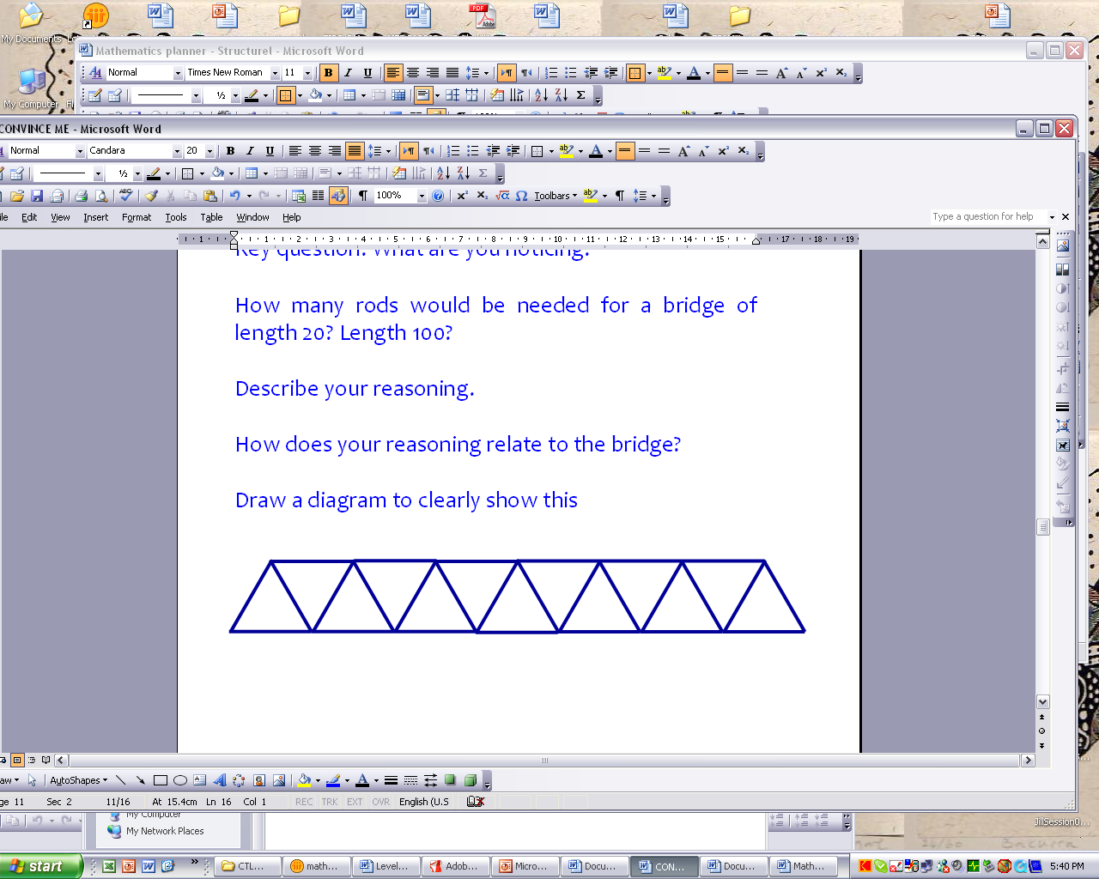
Build a bridge of length 5.
Think about how you built your bridge. Without counting all the matchsticks, calculate how many matches you used. Write an equation to describe your calculation.
How many sticks would be needed for a bridge of length 20?
Figure 7. Task 4: The bridge problem.
The coloured squares matchstick task (Task 5, Figure 8) from Küchemann and Hoyles (2008, p. 2.5) is particularly useful when working with students who have not previously used colour to illustrate their mathematical thinking. The focus of the task is “to look for structure rather than data” (Küchemann, & Hoyles, p. 2.5). Again this task is often presented by showing or having students construct several different sized squares. In these situations, students tend to attend to the iterative, rather than general pattern.
Here is a 3 by 3 square of matchsticks.  Find an efficient way to find the total number of matchsticks and show this by colouring groups of matches.  How many matchsticks are needed for a 20 by 20 square? An n by n square? | 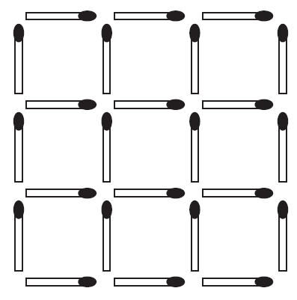
Figure 8. Task 5: Coloured Square Matchstick problem.
There are many equivalent ways of ‘seeing’ this pattern, two of these are shown in Figure 9. The first diagram shows seeing four sets of three vertical matches and three sets of four horizontal matches. Some students represented this as $4×3+3×4$. The next step would be to identify how the numbers 4 and 3 related to the pattern, what the corresponding numbers might be for a 20 by 20 square, and how such thinking could be generalised. The second colouring shown in Figure 9 represents seeing a row of three horizontal matches at the base of the figure, and then three sets of seven matches, that is, $3+3×7$. Again the next step is to identify how each number relates to the structure of the design. Asking students to begin by doing different colourings facilitates their ability to switch from one way of seeing the pattern to another. This task not only promotes within problem flexibility, it also supports students in recognising which colourings, or ways of seeing, are generalisable to larger squares and which are not.

Figure 9. Different colourings for the Coloured Square Matchstick problem.
The first part of the five card task (Task 6) is presented in Figure 9 (Source: http://www.ioe.ac.uk/proof/techreps.html). A large set of cards is used to introduce the task. After some time exploring this task, student pairs get a sense of whether the statement is true or not. Students using concrete materials, that is, scraps of paper numbered on both sides are more likely to believe that the statement was true than those who do not. Student pairs subsequently begin to try to convince other pairs or the whole class of their thinking.
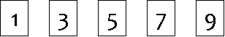
Five cards have the odd numbers 1, 3, 5, 7 and 9 printed on one side, and the even numbers 2, 4, 6, 8 and 10 printed on the other side.
The cards are dropped on the floor and spread out.
Amina, Ben, Carol and Davor are discussing whether this statement is true:
When two of the visible numbers are even, the five visible numbers add up to 27.
What do you think?
Figure 10. Task 6: The five card task
When attempting to convince the whole class, use of the set of large cards, used for the demonstration of the task, resulted in this being unsuccessful. Either students tried to use two numbers from the same card or incorrectly identified the number of visible even numbers. The first of these was identified by the student pairs and the second by other class members. After many pairs of students, unsuccessfully attempting to convince the whole class that the statement was false, all students began to get a sense that the statement was true, that is, when two of the visible numbers are even, the five visible numbers add up to 27. However, providing a convincing argument is more difficult.
The second part of this task involved looking at the arguments of five other students, four of which are shown in Figure 11. Interestingly, in one class Carol’s argument proved so convincing that a number of students changed their minds about the truth of the given statement. Davor’s was generally recognised as looking at one particular case and therefore not being particularly convincing at all.
Amina’s answer  I tried this example:  1, 4, 6, 7, 9  I then tried 2 more examples.  Each had 2 even numbers and the total came to 27 each time. I could try other examples with 2 even numbers, they would come to 27 as well.  So Amina says it is true |  | Ben’s answer  I tried all the odd numbers first and got 25.  1 + 3 + 5 + 7 + 9 = 25  If I change one odd number to an even number the total will be one bigger.  So if I have 2 even numbers the total will be 2 bigger.  So the total will be 27.  So Ben says it’s true
Carol’s answer  I write down these numbers:  1, 2, 3, 4, 9  Two of the visible numbers are even but the total is 19. So you do not always get 27.  So Carol says it is not true |  | Davor’s answer  I thought of these as the visible numbers:  1, 3, 6, 8, 9  Two of them are even and when I add all the numbers I get 27.  So Davor says it’s true
Figure 11. Evaluating and learning from the mathematical arguments of others
This task can also be twisted slightly to consider many ‘what ifs’.
- What if three of the visible numbers are even?
- What if two of the visible numbers are odd?
- What if there are six cards? 10 cards?
- What if the lowest number on the cards is 10? 50? 100?
- What if the numbers on the cards are consecutive odd numbers?

Further consideration of the bridge task
The construction shown in Figure 12 allows no insight into the builder’s thinking. In contrasting colours shown in Figures 13 and 14 not only allow the builder’s thinking to become more transparent, they also support the builder to better see the generality in the structure. Figure 13 shows a way of seeing such that the number of matches on the base is equal to the number of spans (that is 5, 7, or n). Each span then has 2 matches above to create the triangle (that is 2 ×5, 2 ×7, or 2 ×n). Across the top of the bridge matches the number of matches required is one less than the number of spans (that is, 5 – 1, 7 – 1, or n – 1). This results in a general rule of $\text{Total Number}\text{of}\text{Matches}=\text{number}\text{of}\text{spans}+\text{number}\text{of}\text{spans}×2+(\text{number}\text{of}\text{spans}−1)$ or $T=n+n×2+(n−1)$.
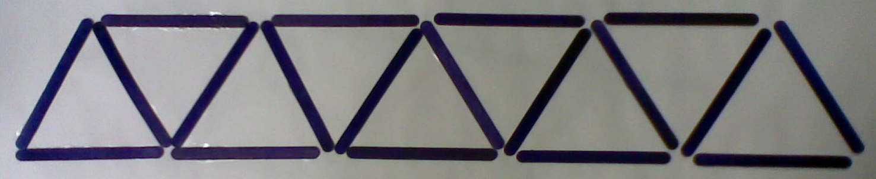

Figure 12. Bridge construction allowing no insight into the builder’s thinking
The 5 span bridge
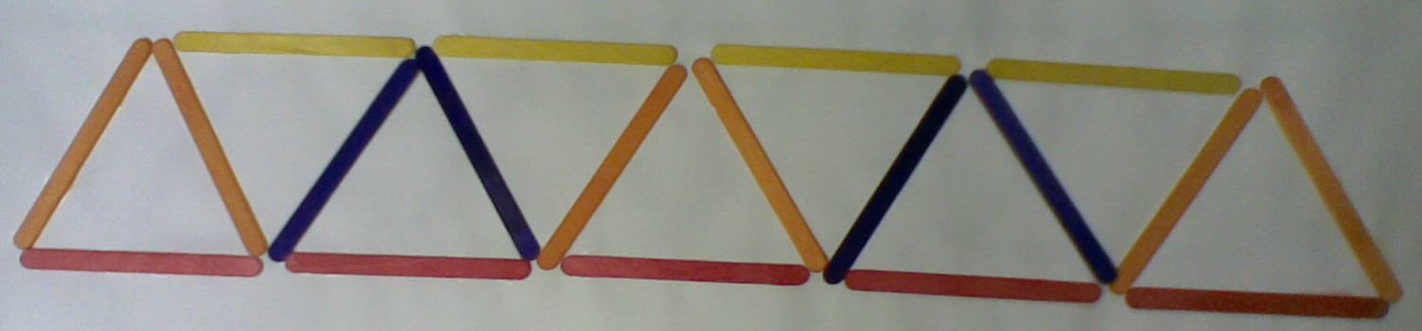
If T represents the total number of matches required, then seeing the structure as shown above, gives for
a 5 span bridge | a 7 span bridge | an n span bridge
$$T=5+5×2+4$$ | $$T=7+7×2+6$$ | $$T=n+n×2+(n−1)$$
Figure 13. Structure in the bridge task
Figure 14 shows a different way of seeing the structure. The bridge begins with a triangle of three matches. Each subsequent additional span requires four matches. This way of seeing results in the equation: $T=3+(n−1)×4$ which is equivalent to $T=n+n×2+(n−1)$.
The 5 span bridge
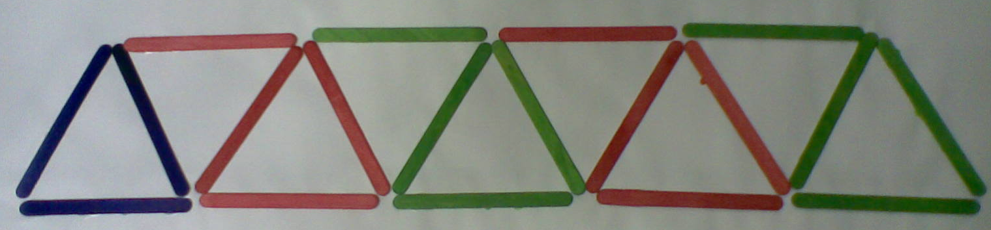
If T represents the total number of matches required, then for
a 5 span bridge | a 7 span bridge | an n span bridge
$$\begin{aligned}T=3+4×4 \\ =3+(5−1)×4\end{aligned}$$ | $$\begin{aligned}T=3+6×4 \\ =3+(7−1)\end{aligned}$$ | $$T=3+(n−1)×4$$
Figure 14. Structure in the bridge task
Additional ways of seeing the structure are shown in the Appendix. The following equations show the general equations for these four ways. Each part of each equation can clearly be related to the way the bridge is constructed as shown by the use of coloured sticks.
- $$T=n+n×2+(n−1)$$
- $$T=3+(n−1)×4$$
- $$T=n×3+(n−1)$$
- $$T=n×3+(n−1)×3−(n−1)×2$$

Conclusion
As one project teacher noted ‘it is just amazing the level of thinking that the children have when you give them time and allow them to talk about what they have done’. A series of tasks have been presented here, as have ideas regrading ways of thinking mathematically. Implemented together, these should support a deepening understanding by students of structure and mathematics more generally.

Acknowledgements
Thanks to my colleagues at ACU in the CTLM team and to the teachers in project, particularly those who invited me into their classrooms.

References
Falkner, K., Levi, L., & Carpenter, T. (1999). Children’s understanding of equality: A foundation for algebra. Teaching Children Mathematics, 6(4), 232-236. Available from http://www.wcer.wisc.edu/NCISLA/publications/articles/ AlgebraNCTM.pdf
Krutetskii, V. A. (1976). The psychology of mathematical abilities in school children. J. Kilpatrick & I.Wirszup, (Eds.), (J. Teller, Trans). Chicago: University of Chicago Press.
Küchemann, D. & Hoyles, C. (2000). Longitudinal proof project: Technical reports for years 8, 9 and 10. London: Institute of Education, University of London. Available from: http://www.ioe.ac.uk/proof/techreps.html
Küchemann, D. & Hoyles, C. (2008). Looking for structure: A report of the Proof Materials Project. London: Dexter Graphics. Retrieved 18 August, 2008, from http://www.ioe.ac.uk/proof/pmpREPORT/2008pmpREPORTweb.pdf
Lowe, I., & Lovitt, C. (1984). Reality in Mathematics Education (RIME) lesson pack. Melbourne: Ministry of Education.
Rachlin, S. (1992). The research agenda in algebra – A curriculum perspective. In Numeracy to algebra, second mathematics teaching and learning conference, QUT.
Reiss, K. M., Heinze, A., Renkl, A., & Groβ, C. (2008). Reasoning and proof in geometry: Effects of a learning environment based on heuristic worked-out examples. ZDM: the International Journal on Mathematics Education, 40(3), 455–467.
Shulman, L.S. (1986). Those Who Understand: Knowledge Growth in Teaching. Educational Researcher, 15(2), 4–14.
Stillman, G. A. (1993). Metacognition and mathematical learning. Unpublished masters of educational studies thesis, University of Queensland, Brisbane.
Victorian Curriculum & Assessment Authority (VCAA) (2002). Mathematics: Reasoning & Strategies levels 1–6. Melbourne: VCAA. Available www.vcaa. vic.edu.au/prep10/csf/publications/MATHS/ReasoningStrat/reasonstrat.html
Victorian Curriculum & Assessment Authority (VCAA) (2008). Victorian Essential Learning Standards (VELS): Discipline-based learning strand, mathematics. Melbourne: VCAA.
Wood, T. (2002). What does it mean to teach mathematics differently? In B. Barton, K. C. Irwin, M. Pfannkuch & M. Thomas (Eds.), Mathematics education in the South Pacific (Proceedings of the 25th annual conference of MERGA,Vol. 1, pp. 61–67), Auckland. Sydney: MERGA. Available: http://www.nzcer.org.nz/pdfs/BES016.pdf
Appendix: Ways of seeing the structure in the bridge problem
The 5 span bridge
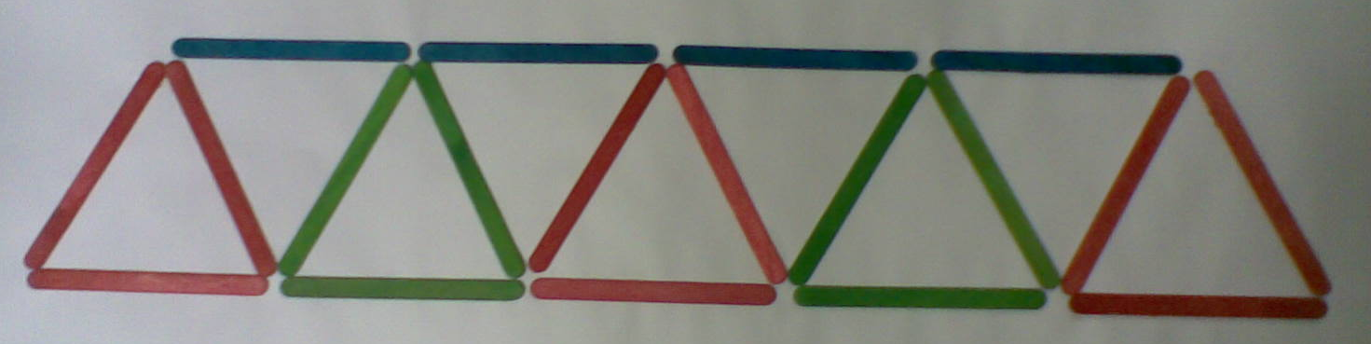
If T represents the total number of matches required, then for
a 5 span bridge | a 7 span bridge | an n span bridge
$$\begin{aligned}T=5´3+4 \\ =5´3+(5−1)\end{aligned}$$ | $$\begin{aligned}T=7´3+6 \\ =7´3+(7−1)\end{aligned}$$ | $$T=n´3+(n−1)$$

The 5 span bridge
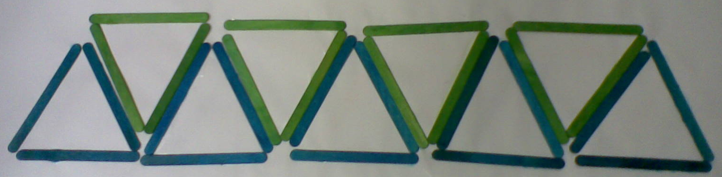
If T represents the total number of matches required, then for
a 5 span bridge | an n span bridge
$$\begin{aligned}T=5´3+4´3−4´2 \\ =5´3+(5−1)´3−(5−1)´2\end{aligned}$$ | $$T=n´3+(n−1)´3−(n−1)´2$$

