Improving Middle School Students’ Proportional Reasoning

Kim Beswick

University of Tasmania
The development of students’ proportional reasoning is a key concern of middle school mathematics and is related to many topics with which students experience difficulties. Carefully chosen tasks can reveal much about students’ understandings of mathematical concepts and are hence valuable parts of teachers’ repertoires. This paper presents a range of student responses to tasks, to illustrate both the potential value of well chosen tasks for teaching, and the diversity of students’ proportional thinking.

Introduction
The central importance of proportional reasoning was emphasised by Lamon (1993) in referring to earlier work by Lesh, Post and Behr (1988) who described it as, among other things, “a cornerstone of higher mathematics” (Lamon, 1993, p. 41). Proportional thinking is inherent in exploring relationships between quantities that are related multiplicatively. It is typically first encountered in relation to fractions, in which the numerator and denominator express a relationship between two quantities as well as together representing a discrete number. Fractions can, of course, be represented as decimals or percents, and are particular examples of (usually part: whole) ratios. Proportions refer to the equivalence of two such relational quantities, for example, when we want to find the number of eighths equivalent to three quarters. The development of proportional reasoning is therefore inextricably linked with understandings of ratio including the various representations of fractions.
This paper illustrates how students’ responses to carefully chosen tasks can be a key tool for teachers in building an understanding of students’ thinking with a view to moving that thinking forward.

Why try to understand students’ thinking?
The answer to this question depends upon one’s beliefs about the nature of learning and hence the purposes of teaching. If one sees learning as the acquisition of fixed body of knowledge then the teachers’ role can be seen as simply conveying that body of knowledge. There would be no imperative to connect with students’ existing understanding since the objective would be to replace them.
From a constructivist point of view, however, learning is the process whereby knowledge is created in response to experiences, including interactions with others. It is dependent upon existing knowledge and hence is idiosyncratic in that different learners will construct differing knowledge in response to the same experience. As a theory of learning constructivism does not prescribe any particular approach to teaching but it does have implications for teaching which include the need for the teacher to build models of student thinking (Confrey, 1990). That is, through their interactions with learners, teachers construct their own knowledge of students’ mathematical thinking as well as of learners’ personal and affective characteristics that are relevant to their learning of mathematics. Parts of these images relate to particular learners while others concern a more generalised learner (Thompson, 2002). Such images of learners’ thinking are crucial because the goal of teaching is to assist learners in building increasingly powerful constructions (Confrey, 1990). In this context the power of a construction refers to its usefulness in making sense of the broadest possible range of experience and includes its consistency with widely held, socially accepted ideas. Thus, if the teacher’s objective is to change learners’ thinking (rather than merely their behaviour), then (s)he needs to understand their thinking and to use that understanding to plan learning experiences likely to advance that thinking.

The role of tasks in uncovering student thinking
According to Cohen (2008) teachers who regard knowledge as constructed can assist students by unpacking the knowledge that they intend students to learn by using many different representations, examples and experiences which combine to increase the learner’s opportunities to develop rich constructions. Tasks are part of this repertoire and students’ responses to them can provide teachers with insights into learners’ thinking. The potential affordances (Chick, 2007) of tasks thus include not only the opportunities they offer in terms students’ learning but also the possible insights that learners’ responses might provide the teacher. Certainly, the potential of a task to shed light on learners’ developing understandings is one factor that teachers appropriately take into account when they design or choose tasks.

The studies
The tasks and learners’ responses to them that are presented here arose from the Mathematics and Reform Based Learning Environments (MARBLE) professional learning research project and/or the second iteration of another professional learning project for middle school teachers entitled Being Numerate in the Middle Years (BNMY). Aspects of the MARBLE project and its outcomes have been reported in Beswick, Watson and Brown (2006) and Watson, Beswick and Brown (2006), and the BNMY project was described in Watson, Beswick, Caney and Skalicky (2006). The ultimate aim of both projects was to improve middle students’ achievement in mathematics and so a major focus of the professional learning was proportional reasoning and related concepts.
Fifty two middle school teachers and their 650 students participated in the MARBLE project and 43 middle school teachers and their 368 students participated in the BNMY project. In both projects student responses to tasks were used to stimulate teachers’ reflection on their students’ learning and, in the case of MARBLE, as part of the evaluation of the professional learning that was provided. The examples presented here are drawn from the initial student surveys from both projects completed by a total of more than 1000 students in grades 5–8 in Tasmanian schools. Two examples of tasks and students’ responses to them are presented to illustrate the kinds of student thinking they elicited.
The tasks used required students to produce pen and paper responses and since they were parts of surveys rather than the day to day activity of the classroom there was no opportunity to observe students working on them or for students to provide verbal elaborations of their thinking. This was a limitation of the studies to be avoided as much as possible in regular classroom activity especially since such interactions also contribute significantly to teachers’ understanding of the personal and affective factors that impact individual’s mathematics learning.

The tasks
Both of the tasks discussed here were set in realistic contexts which necessarily increase the literacy demands of the tasks. In recognition of this the mathematics teachers and/or research assistants who administered the surveys were able to read the problems to students but not to provide any interpretation of them. All of the tasks included in the survey were either open, or asked students to solve a problem and then to explain their thinking.
The Mary and John problem was used in both projects and is shown in Figure 1 with the space provided for answers removed.

Mary and John both receive pocket money. Mary spends ¼ of hers, and John spends ½ of his.
- Is it possible for Mary to have spent more than John?
- Why do you think this? Explain.

Figure 1. The Mary and John problem.

The Lung Disease task, shown in Figure 2, was used only in the BNMY project.
The following information is from a survey about smoking and lung disease among 250 people.
 | Lung disease | No lung disease | Total
Smoking | 90 | 60 | 150
No smoking | 60 | 40 | 100
Total | 150 | 100 | 250
Using this information, do you think that for this sample of people lung disease was caused by smoking? Explain your answer.

Figure 2. The lung disease problem.

Responses to the Mary and John problem
The rubric used to code students responses to the John and Mary problem is shown in Table 1 along with the percentages of responses from students in the BNMY project in each category.
Table 1. Coding and results for the Mary and John project.
Code | Global Description | % | Sub Category | % | Example(s)
0 | Inappropriate Response | 34.5 | No response/Don’t know. | 15.2
0 | Inappropriate Response | 34.5 | Restating of question/information. | 12.0 | “Because she only spent a 1/4 and John spent 1/2”
0 | Inappropriate Response | 34.5 | Misunderstanding of the fractional values. | 4.1 | “Because 1/4 is more than 1/2”
0 | Inappropriate Response | 34.5 | Idiosyncratic reasoning. | 3.3 | “Because Mary wants to save up”
1 | Partial Response | 33.7 | Displays understanding of 1/2 and 1/4 quantities only. Little or no attempt to integrate into the context. | 30.7 | “Because 1/2 is more than 1/4”
1 | Partial Response | 33.7 | Responses don’t match. | 3.0 | “Yes - Because John might get more pocket money than Mary”
2 | Appropriate Response | 31.8 | Critically examines information and states appropriate reason. | 26.1 | “Because Mary could of got more pocket money than John”  “Because the sentence doesn’t tell you how much they both received if it did you could make a comparison”
2 | Appropriate Response | 31.8 | Critically examines information and states appropriate reasoning with concrete examples | 5.7 | “M could have $8 and spends a 1/4 of it that leaves $6 so she spent $2. J could have $1 and spends 1/2 of it that leaves 50c so he spent 50c 1/2 of it”

Table 1 shows almost equal numbers of students’ responses in each of the broad categories, inappropriate, partial and appropriate. The majority of inappropriate responses involved essentially restatements of the problem. Most of the partial responses referred to the two fractions involved without reference to the whole. The majority of responses that were judged appropriate referred to the need to know the amounts of money that each received, while a small number provided specific examples to illustrate that Mary could indeed have spent more.
The following examples illustrate the range of student responses to the problem. Each is presented along with a discussion of what they might reveal about students’ thinking and how a teacher might respond.
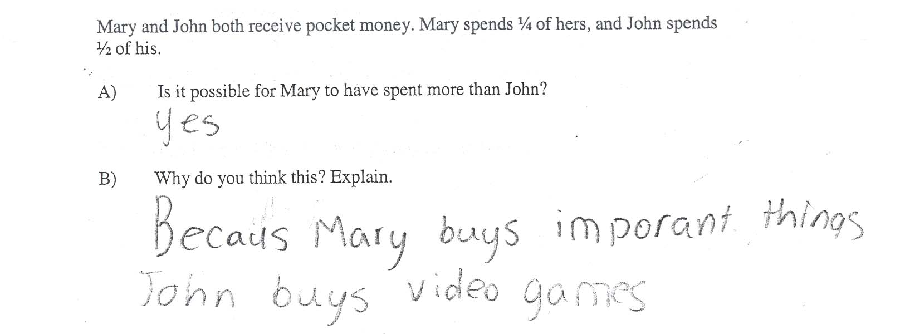

Figure 3. Mary and John example 1.
The response shown in Figure 3 takes no apparent account of the mathematics inherent in the problem even though the answer to part A is correct. It underscores the danger of relying on closed questions (especially when the there are just two choices of answer) and the importance of asking students to explain their reasoning. Subsequent teaching might include assisting this student to identify the mathematically relevant aspects of the problem.

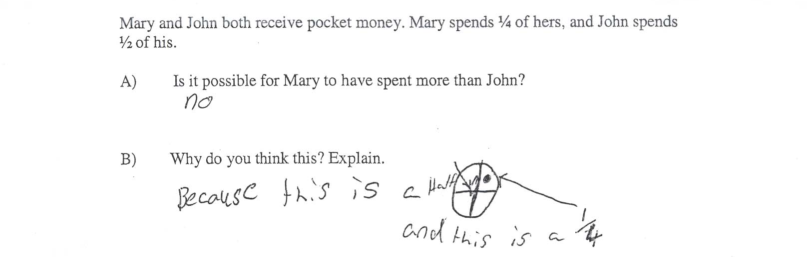

Figure 4. Mary and John example 2.
In contrast with example 1, example 2 shown in Figure 4 illustrates an incorrect response to part A but an explanation that focuses on relevant mathematical ideas although the crucial notion that the relative sizes of fractions is dependent upon the size of the whole is missing. Such reasoning is perhaps unsurprising given that many typical fraction exercises involve working on de-contextualised problems in which there is and un-stated assumption that the wholes to which the various relate are the same. This response might draw a teacher’s attention to make the importance of identifying the whole explicit and, indeed, this task might be chosen with the purpose of finding out about students’ awareness of this issue as well as stimulating their consideration of it.

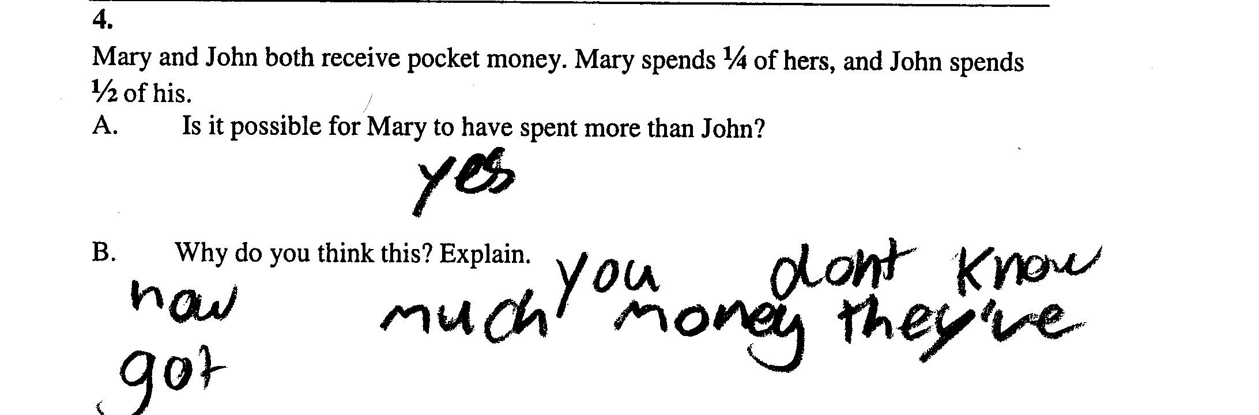

Figure 5. Mary and John example 3.
The example shown in Figure 5 demonstrates recognition that the whole matters but nothing further about how this could affect the comparison of the ½ and the ¼ is offered. Perhaps a teacher could respond by asking this student, “Can you suggest some amounts of pocket money for John and Mary that would make this so?”
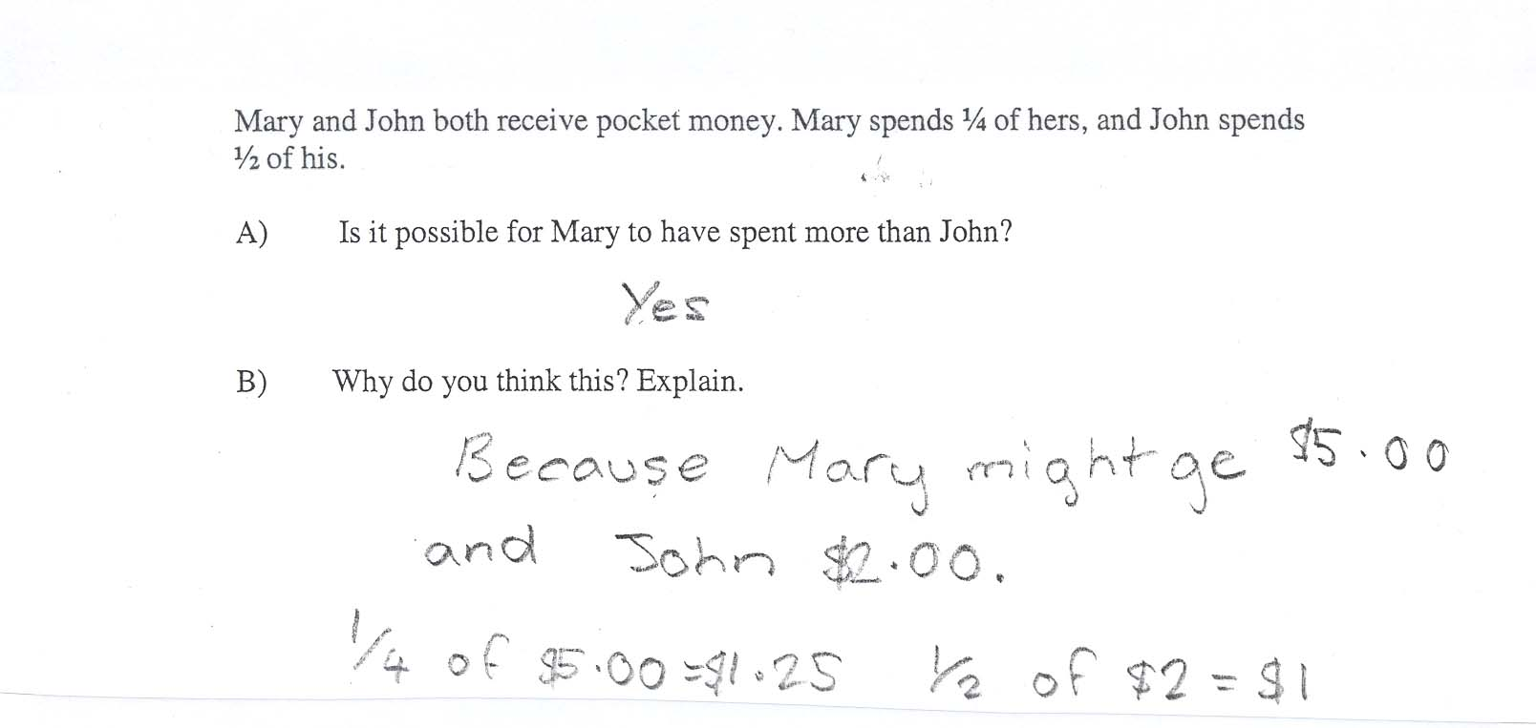

Figure 6. Mary and John example 4.
Finally, the student who produced example 4, shown in Figure 6, illustrated the role of differing wholes by providing a specific example of how differing amounts of pocket money could lead to Mary’s quarter being more than John’s half. None of the students involved in the projects responded at a more sophisticated level than this but there is room to press this student towards a more general conclusion: Asking about other amounts that would work, or about the amounts of pocket money that would make Mary’s quarter equal to John’s half could help.

Responses to the lung disease problem
The rubric used to code student responses to the Lung Disease problem, along with the percentages of responses from students in the BNMY project in each category, are shown in Table 2.
Table 2. Coding and results for the Lung Disease project.
Code | Global Description | % | Sub Category | % | Example(s)
0 | Inappropriate response | 31.6 | No response/Don’t know | 19.0
0 | Inappropriate response | 31.6 | No reason | 9.3 | “Yes I think lung cancer is caused by smoking in the grid.”
0 | Inappropriate response | 31.6 | Positive or negative statement with no justification | 3.4 | “Yes because smoking is bad”  “A lot of people will get it”
1 | Justification or statements not based on the data presented | 32.3 | Positive or negative statements justified with knowledge of the content area, but not based on data | 19.2 | “Yes because when you puff a cigarette it will go directly to your lungs and affect your lungs in many ways.”
1 | Justification or statements not based on the data presented | 32.3 | Agrees or disagrees, stating more/less chance, but with no explicit reference to the data | 3.4 | “Yes there is more chance if you smoke”
1 | Justification or statements not based on the data presented | 32.3 | Argues that smoking is not the only cause of disease or cancer | 9.6 | “No because lung cancer can happen other ways than smoking”
2 | Critical analysis or potential survey methods and the limitations of the methods used to collect the data | 0.7 |  | 0.7 | “We don’t know how they collected their sample. It could be biased”
3 | Partial response based on a single piece of information from the table | 14.8 | Agrees or disagrees with statement, supported by a single descriptive comment | 11.7 | “Yes because smoking has more lung disease”
3 |  | 14.8 | Agrees or disagrees with statement, citing evidence from a single cell in the data | 3.1 | “No because 60 people that don't smoke had lung cancer”  “Because 90 people have lung disease by smoking”
4 | Partial response based on selective information from the table | 18.6 | Agrees or disagrees with statement, supported by a descriptive comparative comment | 7.2 | “Yes because the total of smokers who have lung disease is a larger number than no lung disease and no smoking”
4 |  | 18.6 | Agrees or disagrees with statement, citing evidence from the data focussing within, between or across columns (2-3 cells) | 11.3 | “Because all up 150 people get lung disease 90 of it is by smokers and only 60 of it is not by smoking”
5 | Appropriate responses | 2.1 | Critically examines all information and/or correctly states proportions and percentages | 2.1 | “No. Because there are more people smoking the number with lung disease is higher. But both the smokers and non smokers have 3/5 with lung disease and 2/5 with no disease”

As shown in Table 2, approximately two thirds of the student responses were categorised as inappropriate or made no use of the data in their justification. Most of the remaining third were partial responses relying on single or selected pieces of data from the table. Just over 2% of responses were judged appropriate. Difficulties that students experienced with this problem may have been, at least in part, due to its demands on students’ literacy, including statistical literacy, or to a lack of experience in reading relatively complex tables in addition to the difficulties inherent in proportional reasoning.
The following student responses to this problem illustrate the range of thinking elicited.
The response shown in Figure 7 ignores the data provided, relying instead on existing beliefs about the issue that forms the context of the problem. The bolded phrase in the problem, “Using this information” was insufficient to prevent this. As for the first example in relation to the Mary and John problem, subsequent instruction might helpfully focus on assisting this student to identify the mathematically relevant aspects of the problem and to focus on these. It would be interesting to present such a student with a similarly structured problem but in a less familiar context.
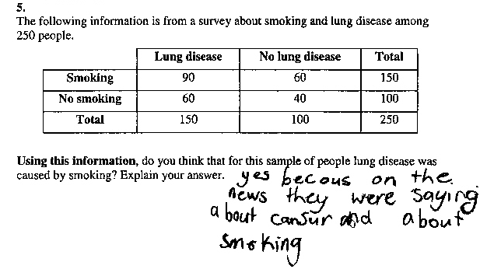

Figure 7. Lung disease example 1.
In example 2, shown in Figure 8, reference is made to the data but the exact numbers referred to are not named. It would be helpful to be able to ask the student about this and to question him/her about the relevance of the other numbers before deciding on a way forward.

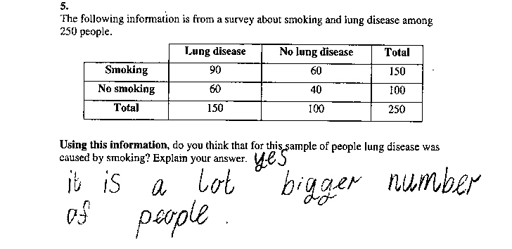

Figure 8. Lung disease example 2.
In the case of example 3, shown in Figure 9, the conclusion appears to be based on a simple comparison of just two numbers from the table. There is no evidence that these numbers were considered in relation to any of the other data provided. The teacher might choose to ask this student about the other numbers and what they tell us about the problem.

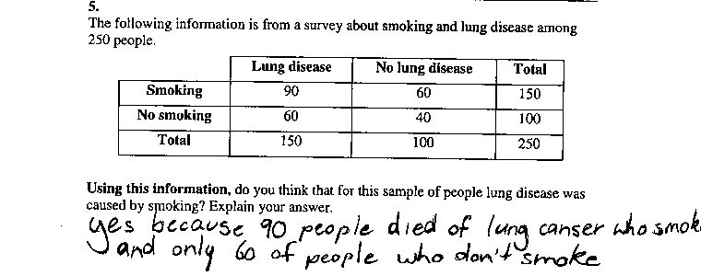

Figure 9. Lung disease example 3.
Example 4, shown in Figure 10, indicates attention to pairs of numbers concerning smokers and non-smokers but not explicitly involving a consideration of the proportions of people with lung disease among these groups. Asking this student to explain more about how the consideration of 90 and 60 for smokers and 60 and 40 for non-smokers lead to the conclusion would be helpful.
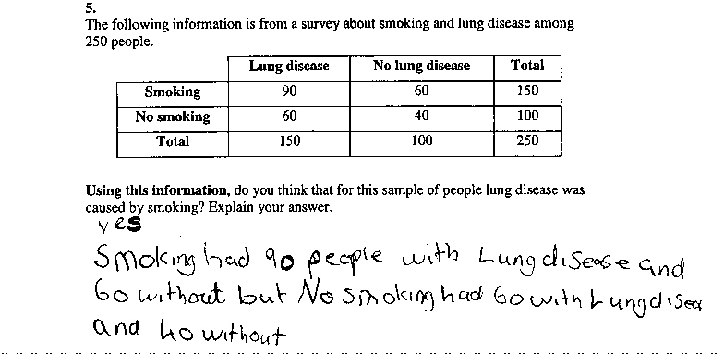

Figure 10. Lung disease example 4.
Finally, example 5, shown in Figure 11, provides some indication that the relative sizes of numbers are being considered, although it is not clear which numbers, and the student was unable to arrive at a conclusion. Again, more information about the student’s thinking would be needed to decide on a way forward. It would be particularly important to explore the student’s understanding of the fact that data showing an association between smoking and lung disease do not imply a causative link.
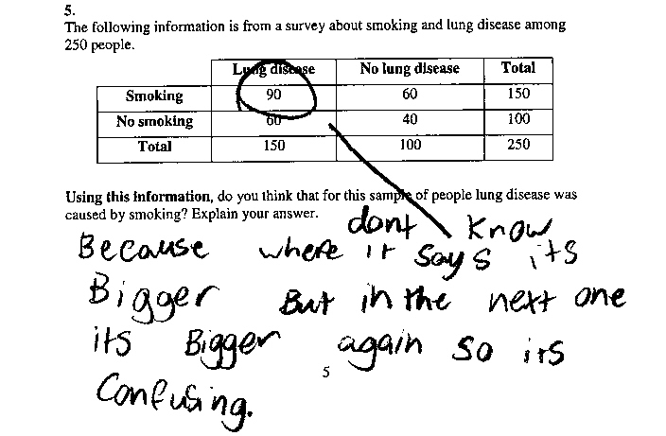

Figure 11. Lung disease example 5.

Conclusions
The examples presented offer insights into the thinking of the particular students who provided them. Considered together there are lessons to be learned about students generally, as learners – of mathematics, and of proportional reasoning in particular.
These examples confirm that middle school students find proportional reasoning very difficult. It has been acknowledged that teaching it and related concepts is a complex process (Adjiage & Pluvinage, 2007) and teachers need to provide many varied experiences for their students, but not just selected randomly. Rather, they need to be chosen or designed on the basis of careful thought about: the nature of students’ current thinking; typical learning trajectories that students follow in relation to the relevant ideas; knowledge of ideas that are potentially difficult or typically un-stated (like the importance of the whole in relation to fractions); an appreciation of the potential uses, or affordances, of various tasks; and a clear vision of where, in terms of their mathematical understanding, the students need to go if they are to construct powerful mathematical knowledge. Tasks like those presented here have a role to play in both uncovering student thinking and moving it forward.
The first examples in relation to both the Mary and John problem and the Lung Disease problem provided no evidence of engagement with the mathematics inherent in the tasks. Instead, these students relied on their own experience and knowledge of these contexts. Exhortations to help students to make connections between school mathematics and ‘real’ contexts abound (Sparrow, 2008) but placing mathematics in such contexts can also create difficulties for some learners. Zevenbergen, Sullivan and Mousley (2001) pointed out the need for contexts to be chosen carefully to be relevant and meaningful to all learners. Perhaps of greater relevance here is their point that the task needs to be made known to students. For example, in relation to the Mary and John problem it might have made a difference to some students’ responses had they been explicitly told that the task was intended to find out about their thinking about fractions (as opposed to pocket money), and in the case of the Lung Disease problem, to find out about how they could use mathematics to justify a conclusion. There are also times when decontextualised problems can be useful in focussing students’ attention on the mathematics, and there is value in explicit discussion around what to ignore in contextualised problems.

References
Adjiage, R., & Pluvinage, F. (2007). An experiment in teaching ratio and proportion. Educational Studies in Mathematics, 65, 149–175.
Beswick, K., Watson, J. M., & Brown, N. (2006). Teachers’ confidence and beliefs and their students’ attitudes to mathematics. In P. Grootenboer, R. Zevenbergen & M. Chinnappan (Eds.), Identities, cultures and learning spaces: Proceedings of the 29th annual conference of the Mathematics Education Research Group of Australasia (Vol. 1, pp. 68–75). Adelaide: MERGA.
Chick, H. (2007). Teaching and learning by example. In J. M. Watson & K. Beswick (Eds.), Mathematics: Essential research, essential practice: Proceedings of the 30th annual conference of the Mathematics Education Research Group of Australasia (Vol. 1, pp. 3–21). Sydney: MERGA.
Cohen, D. K. (2008). Knowledge and teaching. Oxford Review of Education, 34(3), 357–378.
Confrey, J. (1990). What constructivism implies for teaching. In R. B. Davis, C. A. Maher & N. Noddings (Eds.), Constructivist views on the teaching and learning mathematics (pp. 107–122). Reston, VA: National Council of Teachers of Mathematics.
Lamon, S. J. (1993). Ratio and proportion: Connecting content and children’s thinking. Journal for Research in Mathematics Education, 24(1), 41–61.
Sparrow, L. (2008). Real and relevant mathematics: Is it realistic in the classroom? Australian Primary Mathematics Classroom, 13(2), 4–8.
Thompson, P. W. (2002). Didactic objects and didactic models in radical constructivism. In K. Gravemeijer, R. Lehrer, B. van Oers & L. Verschaffel (Eds.), Symbolising, modeling, and tool use in mathematics education
(pp. 191–212). Dordrecht: Kluwer.
Watson, J. M., Beswick, K., & Brown, N. (2006). Teachers’ knowledge of their students as learners and how to intervene. In P. Grootenboer, R. Zevenbergen & M. Chinnappan (Eds.), Identities, cultures and learning spaces: Proceedings of the 29th annual conference of the Mathematics Education Research Group of Australasia (Vol. 2, pp. 551–558). Adelaide: MERGA.
Watson, J. M., Beswick, K., Caney, A., & Skalicky, J. (2006). Profiling teacher change resulting from a professional learning program in middle school numeracy. Mathematics Teacher Education and Development, 7, 3–17.
Zevenbergen, R., Sullivan, P., & Mousley, J. (2001). Open-ended tasks and barriers to learning: Teachers’ perspectives. Australian Primary Mathematics Classroom, 6(1), 4–7.

