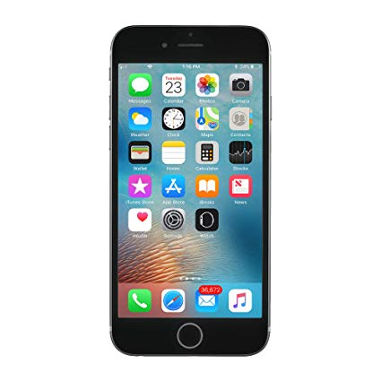
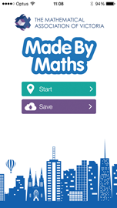
Made By Maths: The app for maths adventures
MAV’s Made By Maths app is a comprehensive guide that explores mathematical beauty of key landmarks, structures and architecture in Melbourne. To enrich learning while using the app itself, this document contains resource materials aimed at supporting teachers to organise their schools and class excursions.

Made By Maths is aimed at students and teachers to connect mathematical classroom learning with real world mathematics. Key mathematical terms are explained and explored through engaging and supportive graphics. The ability to take in-app photos of your journey and complete ‘Things to Do’ challenges further enhances this learning experience.
The content was developed by The Mathematical Association of Victoria, and partners, and is a rich and entertaining source of information. It is aimed at inspiring school students to continue their appreciation of mathematics.
App Features:
- Historical and mathematical information
- Videos, graphics and text that supports mathematical concepts
- ‘Things to Do’ section for each mathematical walk and landmark
- Photo journal – create one for your personal experience
- Self-paced learning
All data collected by the app can be available to view at madebymaths.mav.vic.edu.au if the teacher creates and shares a code for their group. To set up a school or group account, register your details and receive a code at madebymaths.mav.vic.edu.au. Users can still use the app without a class code by selecting ‘Don’t have a code’ however their data will not be collected.
The following advice has been designed to support teachers and leaders to use the app and review the data collected by students at the conclusion of the walk.

Privacy Policy
We do not collect or share personal information captured by the app with third parties.


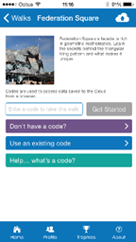
Codes and accounts:
Do I need to register for a teacher account?
- Only if you intend to retrieve and review data collected from your students while using the app.
Do I need to enter a code?
- Only if you are a part of a group where a leader/teacher would like to access the data that you collect while using the app.

Prior to Excursion
This section contains information for students, teachers and parents prior to using the app as a learning experience.

Teacher steps
Step 1: Download and trial the app on your Apple (requires iOS 7.0 or later) or Android device
- iTunes https://itunes.apple.com/au/app/made-by-maths/id892279075?mt=8
- Google Play https://play.google.com/store/apps/details?id=cds.app.mav
Teachers can view the app and walk without setting up a code. Simply follow the student instructions however, when prompted at Step 5, select ‘don’t have a code’. It is strongly recommended that teachers trial the app prior to requesting students to use it.
Step 2: Setting up a teacher account
- Set up a free teacher user account at http://madebymaths.mav.vic.edu.au/
- Obtain a code for your group of students.
Step 3: Advice teachers should provide to students and parents
- Follow the student instructions for downloading and navigation within the app. It is recommended that students complete Step 6 while in class prior to embarking upon an excursion/walk.
- Ensure all media has been downloaded.
- Download media while on a reliable WiFi connection.
- Bring device to school fully charged and with headphones.

Student steps
We recommend that teachers should trial the app and walk prior to asking students to download.
Step 1 | Download Made By Maths on Apple or Android device  iTunes (requires iOS 7.0 or later).  https://itunes.apple.com/au/app/made-by-maths/id892279075?mt=8  Google Play  https://play.google.com/store/apps/details?id=cds.app.mav
Step 2 | Made By Maths  Select: Start.  Note: The Save button is to sync work to the MAV server for teachers to retrieve. | 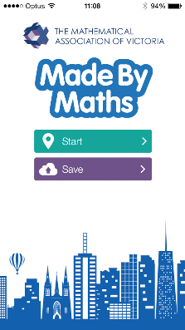
Step 3 | Welcome  Collect Trophies.  Learn About Real Mathematics.  Master “Things To Do”.  Select: Ok | 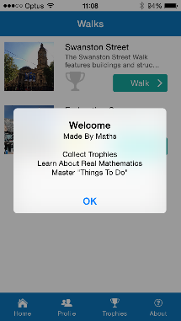
Step 4 | Walks  Select the walk you would like to do e.g. Federation Square.  Note: We strongly suggest that you download on a reliable WiFi connection. | 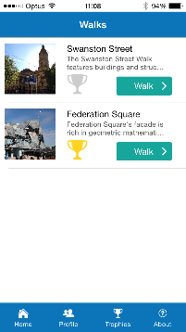
Step 5 | Federation Square  Enter the code your teacher has provided for you in the text box.  Note: Once you have gone through these steps previously, you may select “Use an existing code” and previous codes/walk attempts will be available for you to select. | 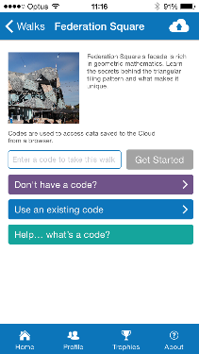
Step 6 | Profile  Fill out your group or individual profile.  Enter group name  Add photo  Enter team members names  Select: Done | 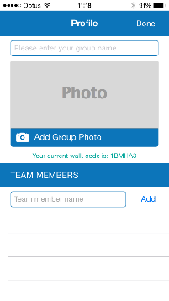
Step 7 | Federation Square  Select: the stop you would like to study  Note:  Home – return to Made By Maths app homepage  Profile – return to Profile  Trophies – view trophy cabinet  About – About MAV | 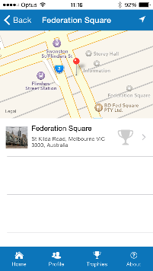
Step 8 | Stop page eg Federation Square  Tap on the media on the left-hand panel to enlarge to the main screen.  Tap on main screen to play movies.  Things To Do – complete challenges to earn a trophy  More – View more information on this destination or relevant curriculum  My Gallery – view photos you have taken through this app  Cloud icon in top right corner – save/sync work to server | 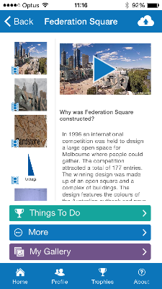
Step 9 | More  If the author of the walk has provided further websites to investigate, select and browse  Note: Each time you select a link it takes you out of the app and launches the page in your internet browser.  When finished browsing exit page and re-launch Made By Maths. | 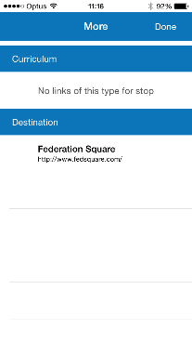
Step 10 | Things To Do  Select each challenge and complete to earn a trophy.  Note: Challenges can be multiple choice, take a photo or create a video.  For photos and video challenges, you can annotate your thinking.  Select: Done | 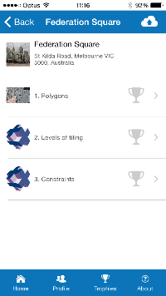
Step 11 | My Gallery  View photos that you have taken for this stop.
Step 12 | Save/sync all work  Note: We strongly suggest that you sync while connected to a reliable WiFi connection.

Post Excursion
This section contains steps for retrieving and reviewing data collected by students. This only applies if students had entered a code as per prior to excursion instructions.
Teachers
Retrieving student work
- Go to http://madebymaths.mav.vic.edu.au/
- Sign In
- Go to My Walks
- Select Walk name and click on Results
- Walk Status: change to Teacher review
- When content is satisfactory
- Walk Status: change to Approved
- Once approved from all Groups view individual group details

Students
Viewing class results
- Go to http://madebymaths.mav.vic.edu.au/
- Select ‘Students’
- Select the walk you did
- Enter the code your teacher gave you
- View data from all groups your teacher has approved for view

